Accessing accessibility resources on the go for AC’s Ottawa Campus just got a whole lot easier! Follow the instructions in this how-to-guide to take full advantage of upgrades to the mobile safety application.
What’s New:
- Easy to find Elevator Location Maps
- One click to “Call Facilities” (reporting issues and accessing support)
- Enable instant notifications direct to your device for all unplanned Ottawa Campus elevator service disruptions ,as well as restored service notices
- Access Push Notification History of elevator outages



Click to Download: Don’t have the app? Download and setup instructions included below.
Already have it downloaded? Skip to page 2 of this guide.

The Mobile Safety app for iphone or Android devices is the official safety app of Algonquin College. The app features emergency contacts, campus maps, crisis alerts, location services features, in-app tip reporting, and much more! Once downloaded, your device may prompt you to allow notifications.
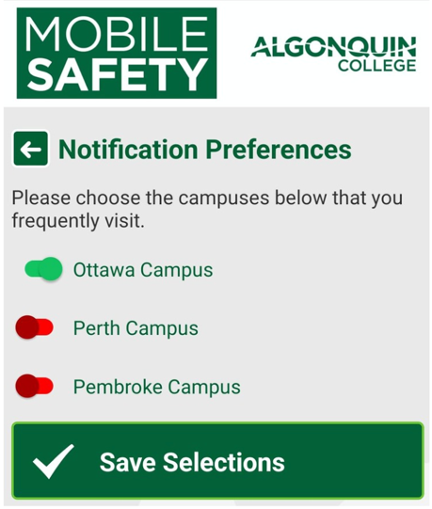
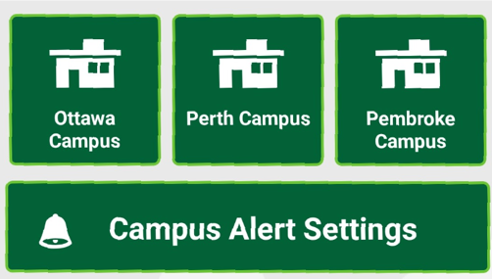
Choose your campus alert settings: Within the application you will be asked to set your notification preferences by campus.
Toggle right to enable notifications. Select those Campuses you frequent most often by toggling to the right (the toggle will turn green if selected).
Don’t forget to save your selections.
The following instructions detail the new accessibility features added to Algonquin College’s official Mobile Safety App! Enable accessibility notifications today to stay in the know about unplanned elevator service disruptions on the Ottawa Campus.
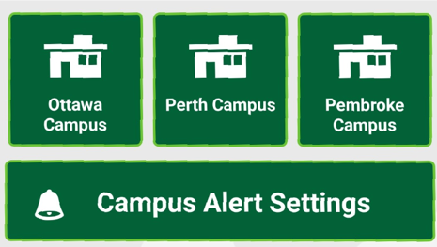
Select Ottawa Campus
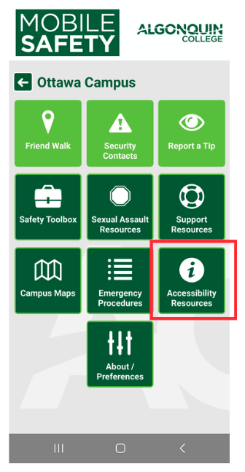
From the home screen, choose the Ottawa Campus. This will bring you to a selection of Ottawa campus safety resources, including the new and improved features for accessibility!
Next, select Accessibility Resources
Selecting Accessibility Resources will bring you to the full suite of new features, including options to call facilities, access elevator location maps, enable accessibility notifications and review push notification history.
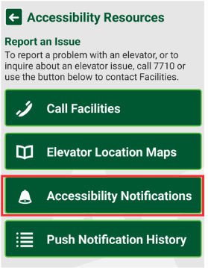

IMPORTANT: Accessibility Notifications must be enabled to receive alerts for elevator outages (See page 3).

After Selecting Accessibility Notifications
Accessibility notifications start off as automatically disabled when you first access this feature, you must ensure notifications are enabled to start receiving notifications about elevator outages.

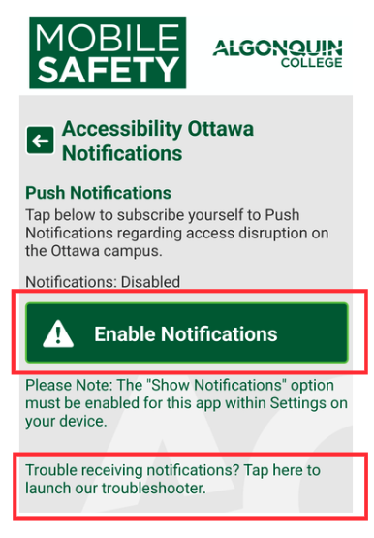
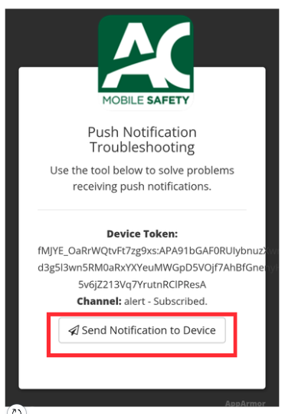
Press the “Enable Notifications” button to turn this feature on. Once enabled and tested you will start receiving accessibility alerts:
See bottom of accessibility notifications page to test notifications system.
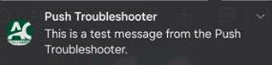
Tap the Troubleshooting launch link to ensure notifications are working. Launch test by selecting “send notification to device.”

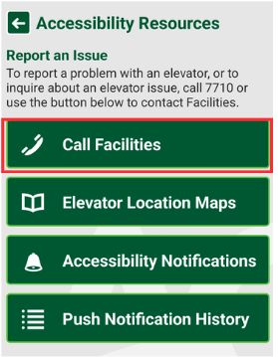
After Selecting Call Facilities
This feature is your one click access to calling a representative from the Ottawa Campus facilities team.
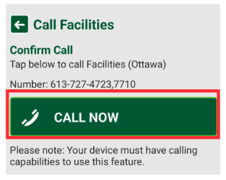
If you know of an outage or service disruption that hasn’t been reported, use this feature to phone it in. Press the “Call Now” Button. You can also reach out for facilities related support using this quick call feature.
After Selecting Elevator Location Map
Press ‘Elevator Location Map’ to navigate to the webpage dedicated to finding your way at the College. Scroll down on the site to view links to campus maps. Scroll down further and you will find the Ottawa Campus Elevator Maps - these simplified maps have been created to assist our community in locating elevator alternatives on campus when outages and service disruptions occur.
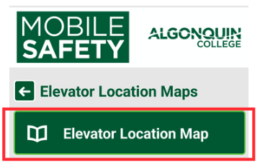
After Selecting Elevator Location Map
Press ‘Elevator Location Map’ to navigate to the webpage dedicated to finding your way at the College. Scroll down on the site to view links to campus maps. Scroll down further and you will find the Ottawa Campus Elevator Maps - these simplified maps have been created to assist our community in locating elevator alternatives on campus when outages and service disruptions occur.
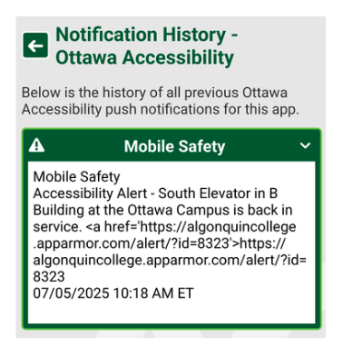

After Selecting Push Notification History
Access history of all mobile safety accessibility alerts, and monitor whether or not elevator service for those you frequently use have been fully restored. Select dropdown arrow beside each individual Mobile Safety notification.

You’re All Set! - If you have questions or need help with the new accessibility resources feature of the app, please send an email to accessibility@algonquincollege.com

