EMAIL SIGNATURE SETUP

Open a new email message
Click the signature icon  , then “Edit Signatures.”

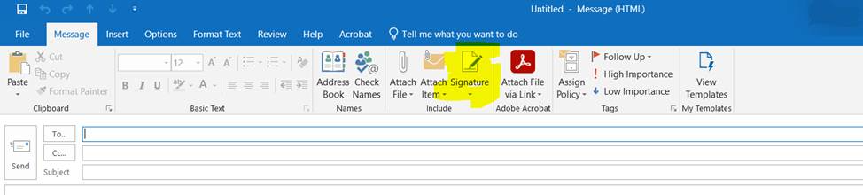

In the popup window, select “New” (or ‘+’ on Mac)
Copy and paste the signature of your choice into the text field
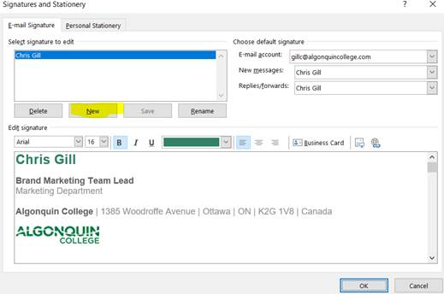
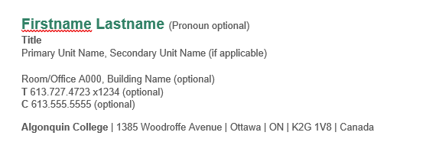

Name the new signature as desired. Then you need to copy the desired signature from the Word doc available on the marketing site.

From there, right click in the edit signatures section and under paste options select keep source formatting: Edit as required

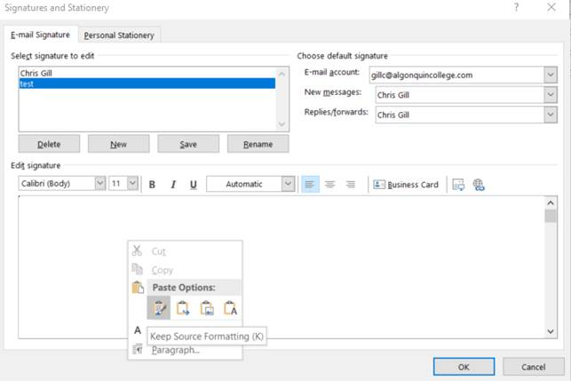

College Logo Versions

Firstname Lastname (Pronoun optional)
Title
Primary Unit Name, Secondary Unit Name (if applicable)
Room/Office A000, Building Name (optional)
T 613.727.4723 x1234 (optional)
C 613.555.5555 (optional)

Algonquin College | 1385 Woodroffe Avenue | Ottawa | ON | K2G 1V8 | Canada


I acknowledge the Anishinàbe Algonquin People whose traditional unceded, unsurrendered territory that I work and live on. (optional)

This email is intended solely for the addressee(s) and is Confidential. If you received this in error, any disclosure, copying, or distribution is prohibited. Please reply and inform the sender and delete all copies. Thank you.

Note:
- Delete optional items if you do not wish to use them
- Building names should be written as Building followed by the building letter. (Building A, Building B etc.)

College Campus Versions

Firstname Lastname (Pronoun optional)
Title
Primary Unit Name, Secondary Unit Name (if applicable)
Room/Office A000, Building Name (optional)
T 613.727.4723 x1234 (optional)
C 613.555.5555 (optional)

Algonquin College | 1385 Woodroffe Avenue | Ottawa | ON | K2G 1V8 | Canada



I acknowledge the Anishinàbe Algonquin People whose traditional unceded, unsurrendered territory that I work and live on. (optional)

This email is intended solely for the addressee(s) and is Confidential. If you received this in error, any disclosure, copying, or distribution is prohibited. Please reply and inform the sender and delete all copies. Thank you.

Note:
- Delete optional items if you do not wish to use them
- Building names should be written as Building followed by the building letter. (Building A, Building B etc.)

School Logo Versions

Firstname Lastname (Pronoun optional)
Title
Primary Unit Name, Secondary Unit Name (if applicable)
Room/Office A000, Building Name (optional)
T 613.727.4723 x1234 (optional)
C 613.555.5555 (optional)

Algonquin College | 1385 Woodroffe Avenue | Ottawa | ON | K2G 1V8 | Canada



This is a place for highlighting special initiatives. (i.e. Celebrating 50 years of Nursing)
I acknowledge the Anishinàbe Algonquin People whose traditional unceded, unsurrendered territory that I work and live on. (optional)

This email is intended solely for the addressee(s) and is Confidential. If you received this in error, any disclosure, copying, or distribution is prohibited. Please reply and inform the sender and delete all copies. Thank you.

Note:
- Delete optional items if you do not wish to use them
- Building names should be written as Building followed by the building letter. (Building A, Building B etc.)
- Special initiative text should be approved prior to use and should be applied consistently for anyone using this text.

Logo Versions (Pembroke Campus)
.
Firstname Lastname (Pronoun optional)
Title
Primary Unit Name, Secondary Unit Name (if applicable)
Room/Office A000 (optional)
T 613.735.4700 x1234 (optional)
C 613.555.5555 (optional)

Algonquin College | 1 College Way | Pembroke | ON | K8A 0C8 | Canada

I acknowledge the Anishinàbe Algonquin People whose traditional unceded, unsurrendered territory that I work and live on. (optional)

This email is intended solely for the addressee(s) and is Confidential. If you received this in error, any disclosure, copying, or distribution is prohibited. Please reply and inform the sender and delete all copies. Thank you.

Note:
- Delete optional items if you do not wish to use them
- Building names should be written as Building followed by the building letter. (Building A, Building B etc.)

Logo Versions (Online Campus)

Firstname Lastname (Pronoun optional)
Title
Primary Unit Name, Secondary Unit Name (if applicable)
Room/Office A000 (optional)
T 613.727.4723 x1234 (optional)
C 613.555.5555 (optional)

Algonquin College | 1385 Woodroffe Avenue | Ottawa | ON | K2G 1V8 | Canada

I acknowledge the Anishinàbe Algonquin People whose traditional unceded, unsurrendered territory that I work and live on. (optional)

This email is intended solely for the addressee(s) and is Confidential. If you received this in error, any disclosure, copying, or distribution is prohibited. Please reply and inform the sender and delete all copies. Thank you.

Note:
- Delete optional items if you do not wish to use them
- Building names should be written as Building followed by the building letter. (Building A, Building B etc.)

