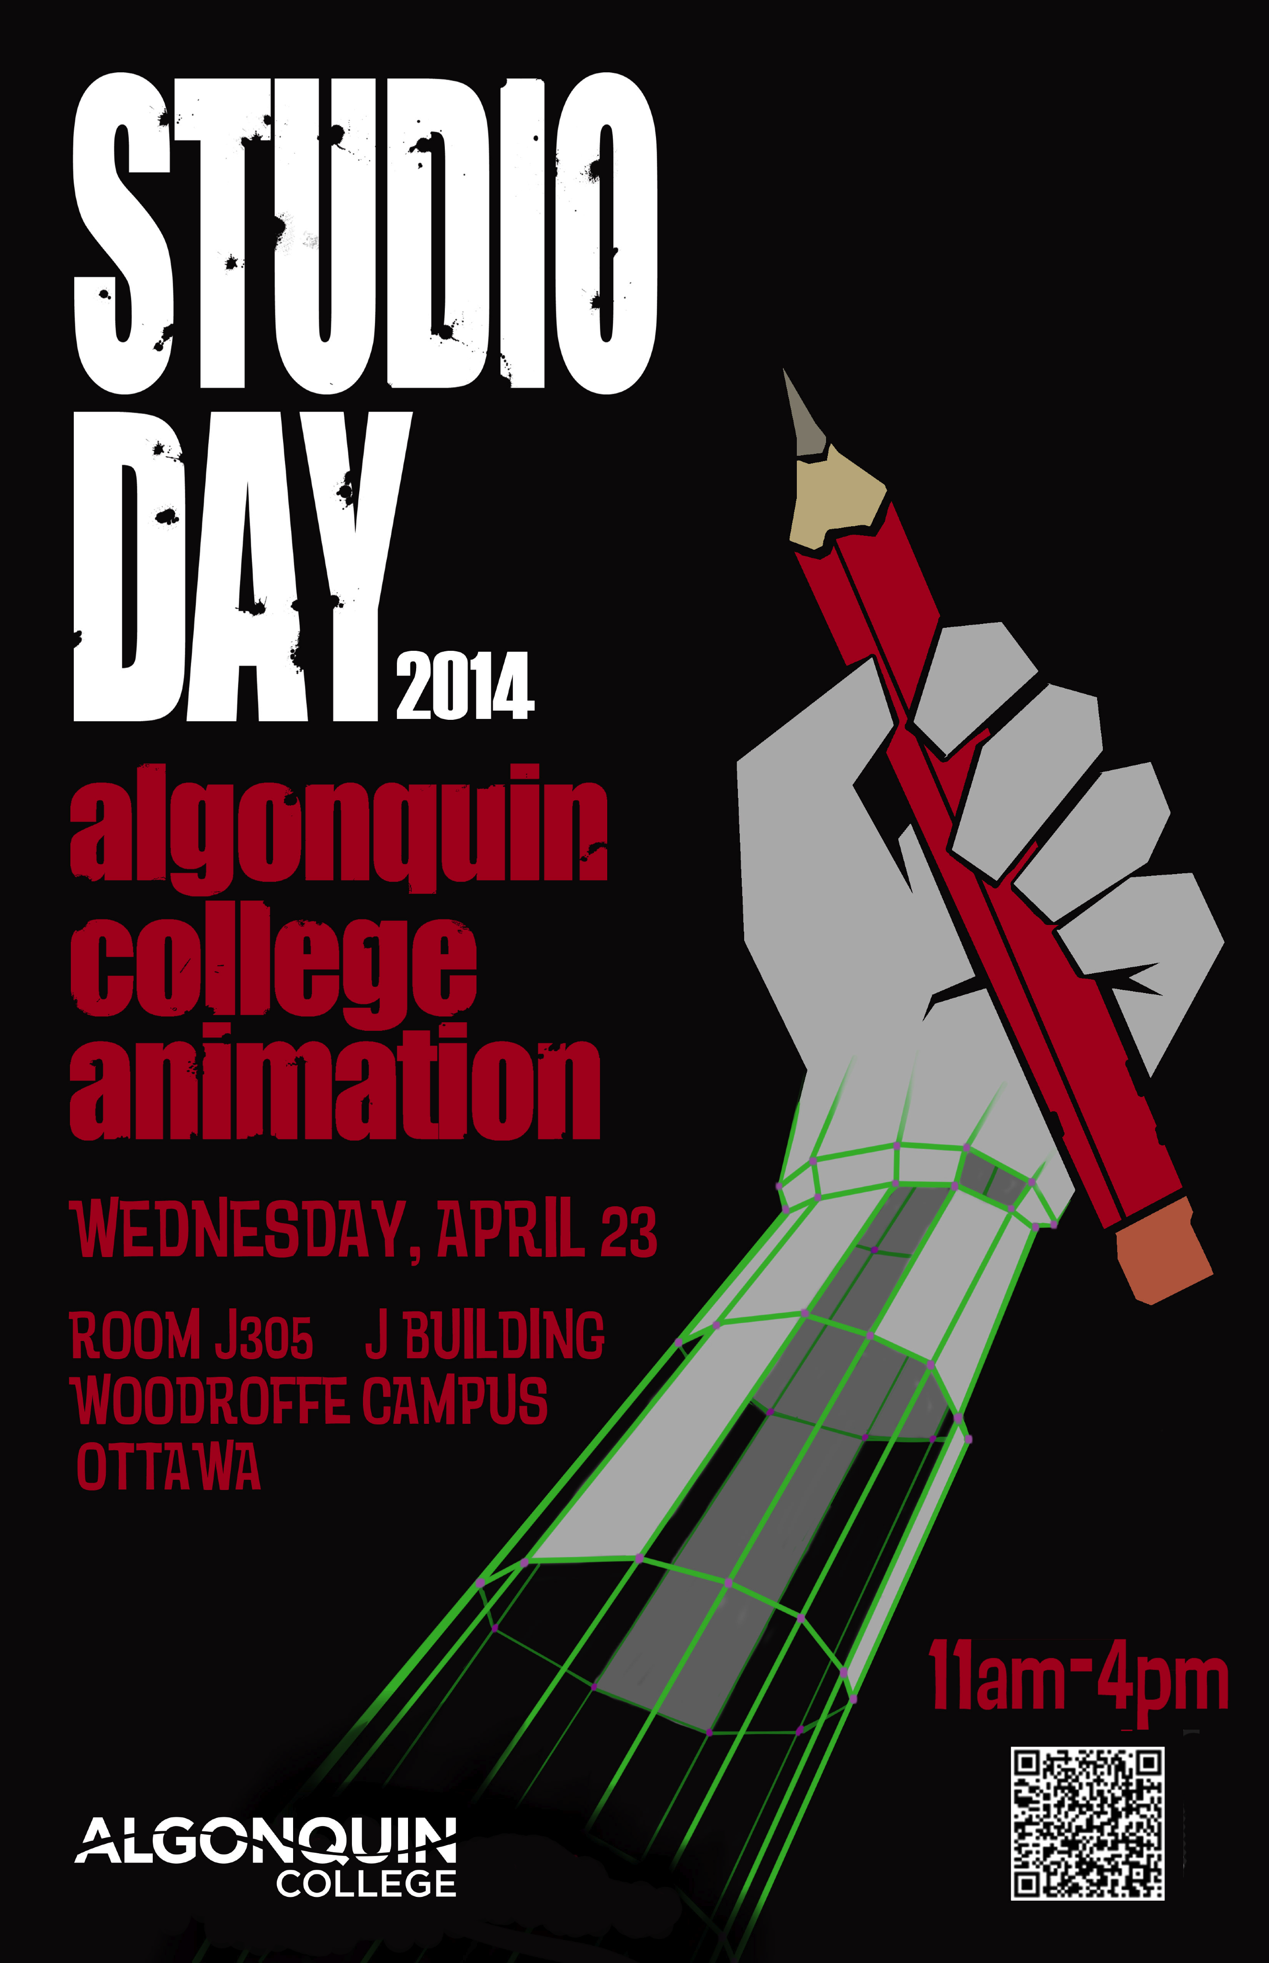
THIRD YEAR BLOGS 2014

Noor Abou-Seido
http://noorabouseido.blogspot.ca/

Kristina Beaton
http://kristinabeaton.blogspot.ca/

Brian Blanchard
http://www.brianblanchard.ca/

Alex Bock
http://alexbock.blogspot.ca/

Bianca Bourbonnais
http://biancabourbonnais.blogspot.ca/

Alex Brown
http://alexcharliebrown.blogspot.ca/

Ewart Cameron
canuklehead.blogspot.com

Andre Catudal
http://andrecatudal.blogspot.ca

YuehWei Chan
http://weiweichan-art.blogspot.ca/

Taylor Anne Cochrane
http://tayloranncochrane.wix.com/tayloranncochrane

Katie Coleman
http://imaginationlastrange.blogspot.ca/

Karla Cons
www.karlacons.com

Breanna-Lee Crabbe
Breanna-Crabbe.blogspot.ca

Dougal Dawson
http://dougalldawson.blogspot.ca/

Erica Dingman
http://ericadingman.blogspot.ca/

Chris Di Saverio
www.chrisdisaverio.blogspot.ca

Noemie Fournier-Leveque
http://noemieart.blogspot.ca/

Alyssa Grant
alyssagrantart.blogspot.ca

Kyle Irvine
http://overstimulatedvisuals.blogspot.ca

Danielle Klassen
http://klassenpd.blogspot.ca/

Marie-Andree Laferriere
marieandreelaferriere.blogspot.ca

Heather Langlois
http://heatherlanglois.blogspot.ca/

Dylan Lincez
http://dylanlincez.blogspot.ca/

Rebecca Loerts
http://loertsrl.blogspot.ca/

Reynaldo Lopez
reylopezart.blogspot.ca

Josh McEvoy
http://joshmcevoy.blogspot.ca/

Ceara Menard
http://cearamenard.blogspot.ca/

Alex Morin
www.morinplex.blogspot.com

Patrick Mota
http://pat-mota.blogspot.ca/

Kate-Lin Osborne
kateosborne.blogspot.ca/

Brennan Payne
www.paynebart.blogspot.ca

Nicole Perrin
http://nicole-perrin.blogspot.com/

Niko Pronko
nikopronko.blogspot.com

Justin Schwartz
justinschwartzart.blogspot.com

Stephanie Staahs-Roquet
roquetink.blogspot.ca

Emilie Tousignant
http://emilietousignant.blogspot.ca/

James Woods
http://jameswoodsanimates.blogspot.ca/

