How to Set-up a Contract in Adobe Acrobat Sign
(Note: You’ll need to obtain IT permission to use the program)

Step 1: Open Adobe Sign | - Open following site in Chrome: https://algonquincollege.na1.documents.adobe.com/account/homeJS
Step 2: Navigate to the Home tab and click the Request Signatures button | 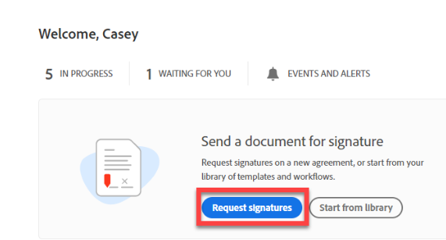
Step 3: Define the recipients of the agreement. | - Define each recipient, in the order they are to take action on the agreement  - Place fields specifically for each recipient as necessary  - To add yourself to the list of recipients, click the Add Me link in the upper right corner.  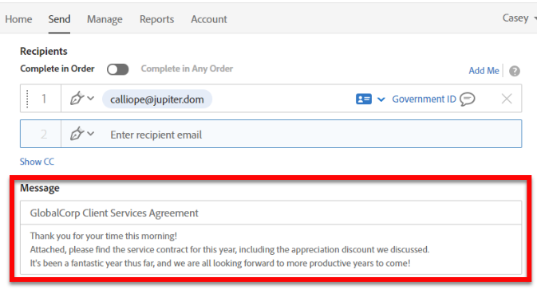
Step 4: Add an Agreement Name and Message that will be included in the initial email to the recipient.
Step 5: Drag-and-drop, attach, files for review | 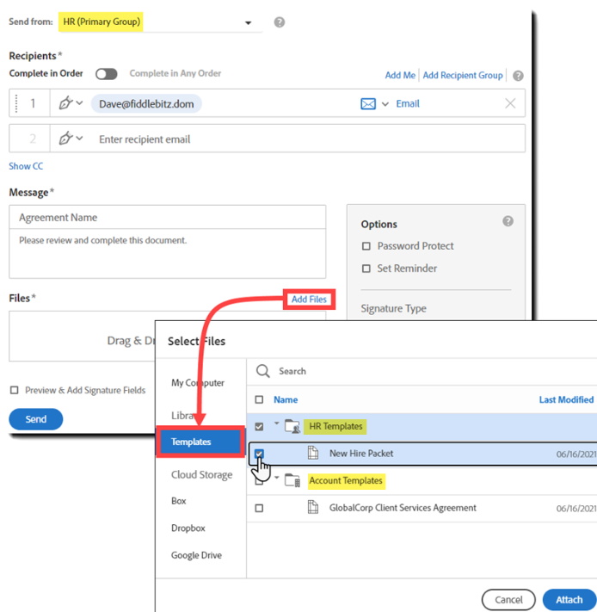
Step 6: Once all files are added click next | 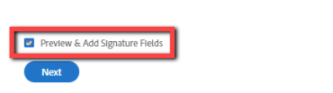
Step 7: Drag fields from the tabs on the right of the screen and drop the fields on the document. | 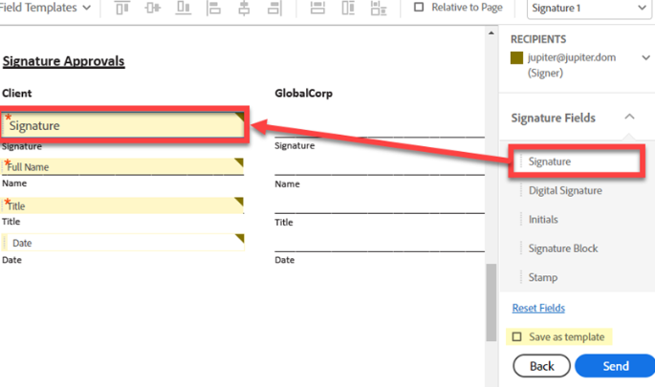  When finished hit send
Step 8: Add comment box: Open Recipients, choose Anyone | 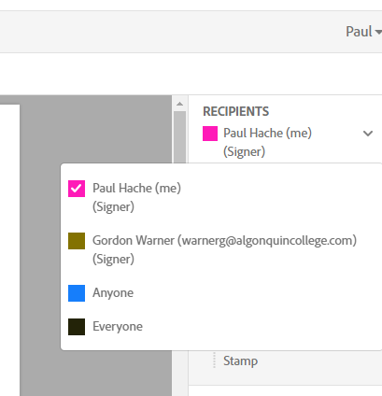
Step 9: Select Data Fields-Text Input, and drag it into bottom box on signing sheet, then enlarge to fit box | 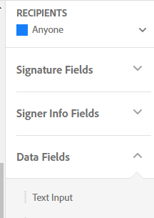
Step 10: Double click in box, then check multi-line data entry, click OK | 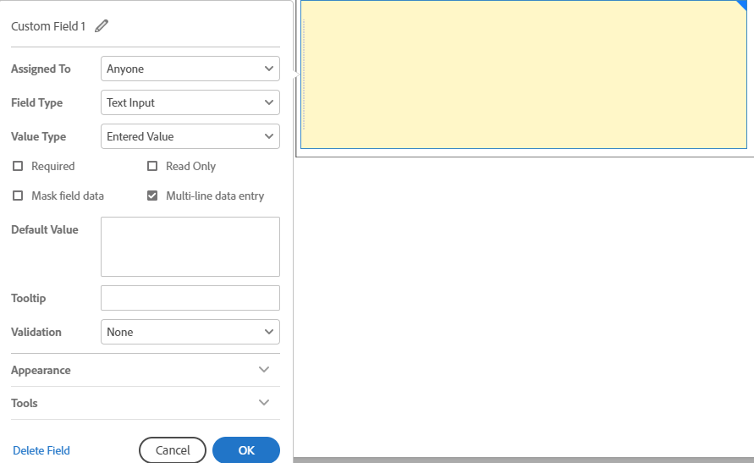
Step 11: Click Send | Created Request is sent to the required signees in the order  Identified in Step 3 above.
Step 12: Signing Request is Processed | - Adobe Sign will alert you via email as each signee completes their signature  - When final signee completes signature, the finished document is sent to you via email
Step 13: Signed Document | - Final document will come back in the format that you sent to get signed. ( complete with additional backup files)
Step 14: Edit final signed document

