How to Set-up a Contract in Bonfire Contract Load
(Note: Login credentials can be requested from contractadministration@algonquincollege.com )

Adding and Setting Up a New Contract
Step 1:  Adding a New Contract | 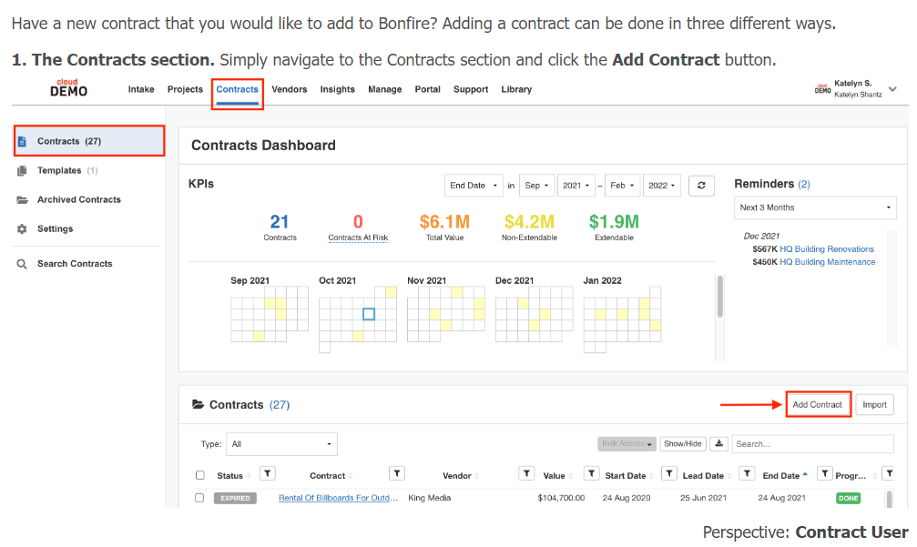
Step 2:  Setting Up a New Contract-Part 1 | 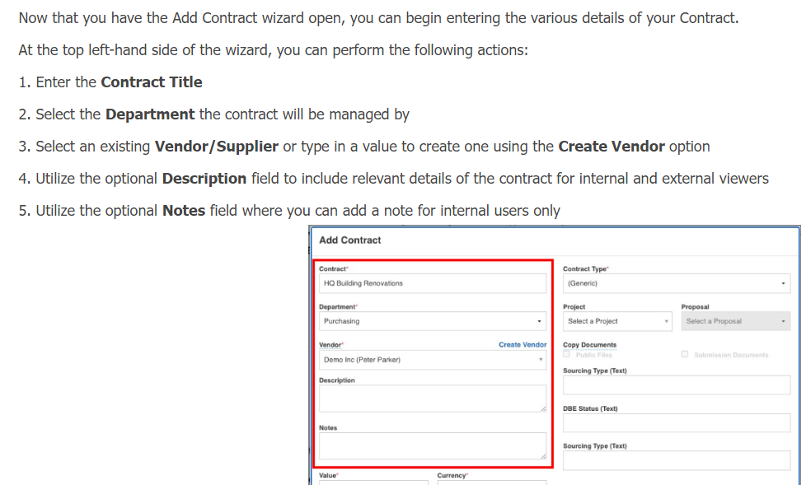
Step 2:  Setting Up a New Contract-Part 2 | 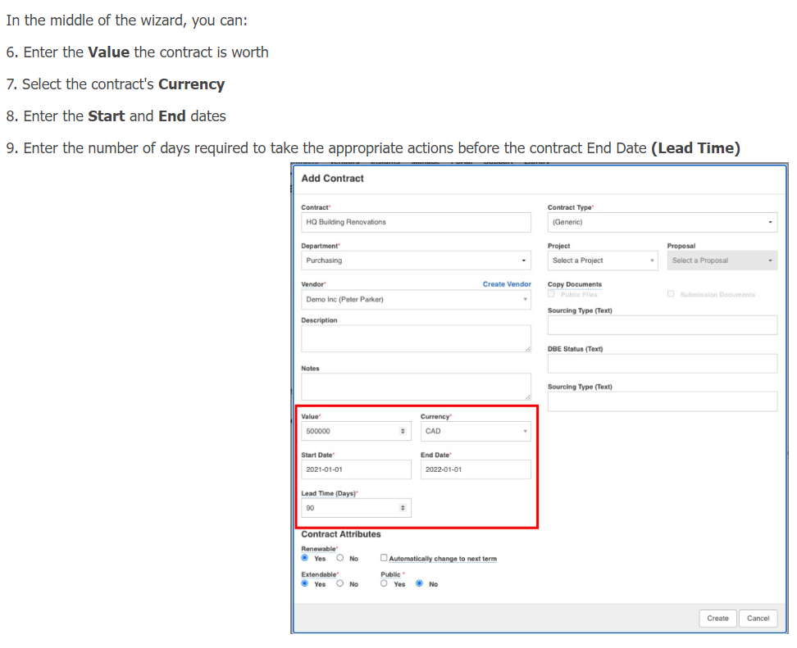
Step 2:  Setting Up a New Contract-Part 3 | 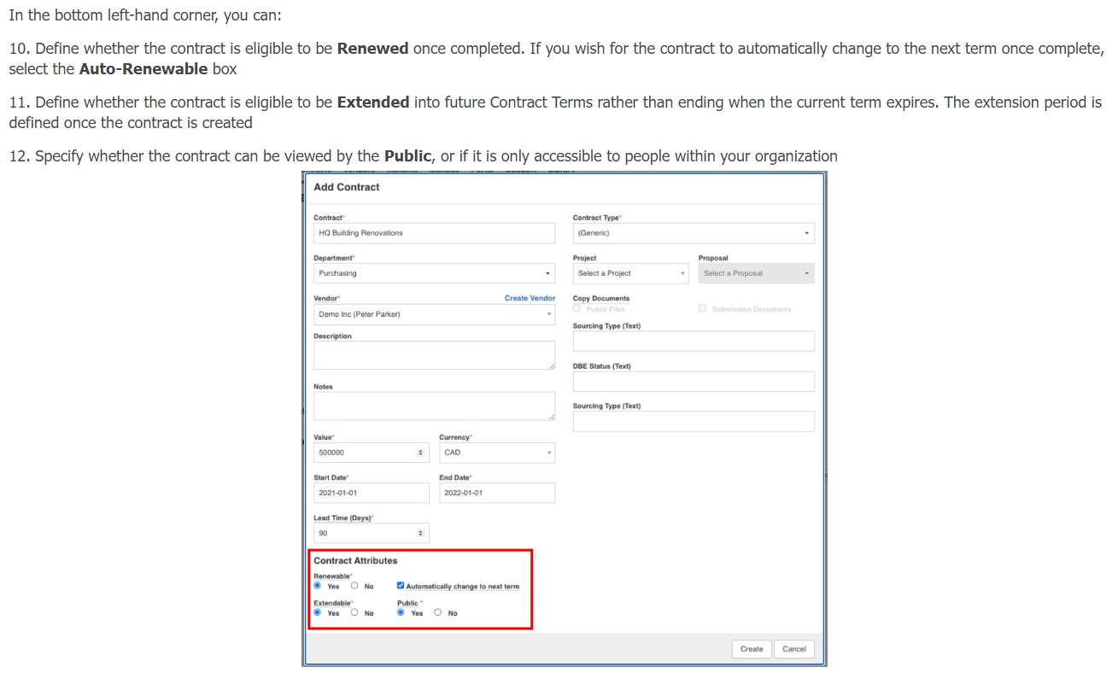
Step 2:  Setting Up a New Contract-Part 4 | 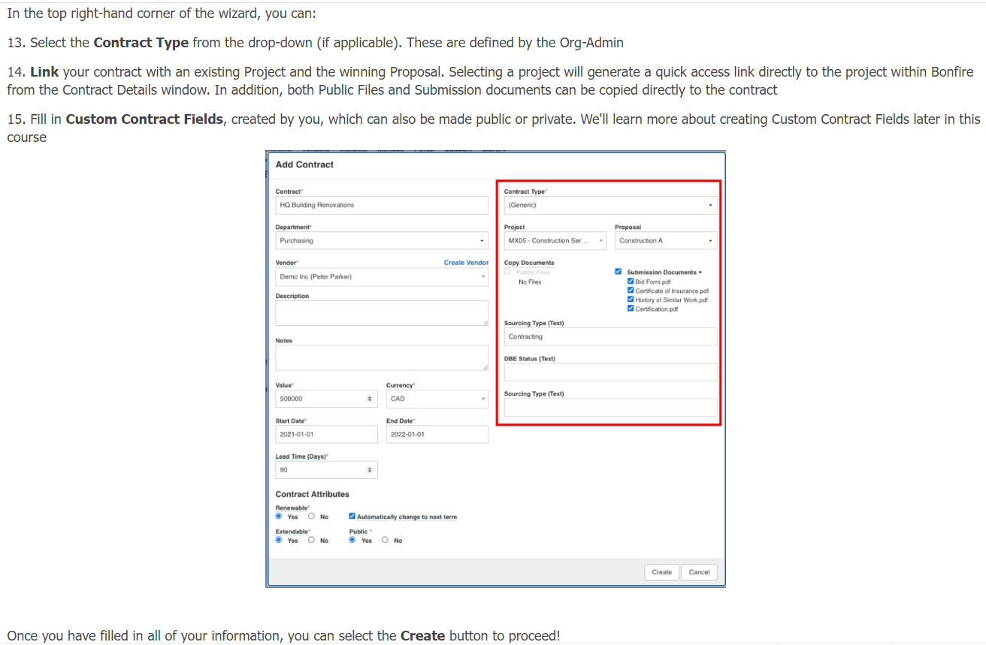
Step 2:  Setting Up a New Contract-Part 5 | When updating the contract, put in the main Contract Contact Person in the field of Budget Manager  - This will enable you to search by the persons name  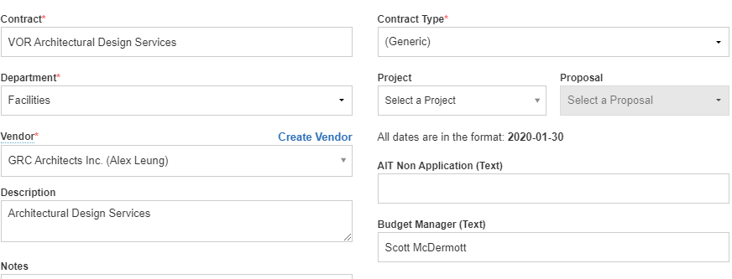
Step 2:  Setting Up a New Contract-Part 6 | Under the People category put in your name as well as the main Contract Contact Person. This will ensure that the auto reminders go out to the appropriate people.  