By this point, you have reviewed Checklist 1: Getting Started with Zoom at Algonquin. This means that you now have a Zoom Pro password. You can find all three Zoom checklists on the LTS Tools for Delivery page.

SCHEDULE YOUR CLASS SESSION
In your Brightspace course:
☐ In the course navigation bar, click: TOOLS > ZOOM CLASSROOM
☐ A new window will open. Select the blue SCHEDULE A NEW MEETING button.

Zoom Session Settings
☐ Add Topic
Include course name and meeting date in the title so students know which ones to attend on which day. E.g: Wednesday March 25 – GEN1001M Intro to Ethics
☐ Set Your Session Day and Time
Tip: Try to schedule your Zoom class session for no longer than 1 hour 30 minutes. For 3 hour classes, consider converting some of this classroom time to independent learning activities or group activities via Break Out Rooms (described later in this document) or, have students collaborate “asynchronously” through collaborative documents in Office 365.

☐ The remaining settings are recommended for the most secure experience, but can be changed. The password is embedded in the Zoom Classroom ‘Start’ button and does not need to be shared with students as long as they join the meeting through Brightspace.
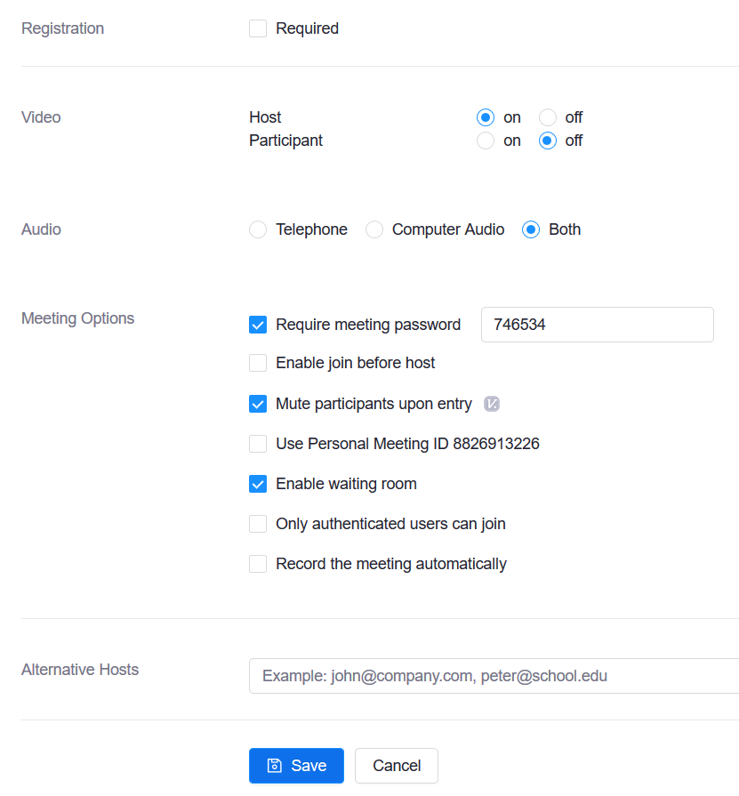

SET UP A PRACTICE SESSION
IMPORTANT NOTE
When you schedule your Zoom class in your course, a link to that session will automatically appear in the course calendar. Avoid setting up “test” Zoom sessions in your actual course. Instead, use either your Sandbox course (if you have one) or request a development course from Brightspace Support (brightspace@algonquincollege.com).

PRACTICE BEING IN YOUR ZOOM CLASSROOM AS A MODERATOR
☐ Create a “test session” OR, “Start” a future session to see what it looks like as a “host”.
☐ Find your tool bar. The tool bar is hidden, but is made visible by hovering your mouse over the bottom of your Zoom screen. As a host or moderator, you will have more tools on your tool bar than your students:
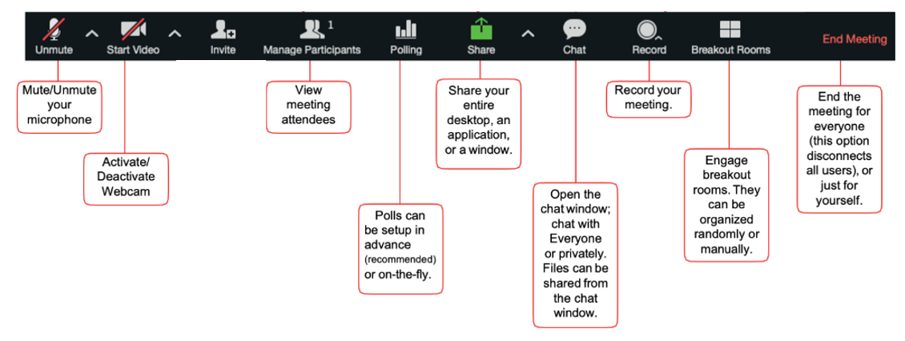
☐ Review what you can do with these key Zoom features in the Appendix to this document.

LAUNCH YOUR CLASS SESSION
On the day of your meeting, go into your Brightspace course:
☐ In the course navigation bar, click: TOOLS > ZOOM CLASSROOM
☐ Go to Upcoming Meetings, then your scheduled meeting, and click Start.

AFTER YOUR MEETING
☐ After some processing time, your video recording will be visible by going to TOOLS > ZOOM CLASSROOM then Recordings. If the session was password protected, a password for the recording will be sent to you by email. Share this with students.
☐ You can see your Attendance List by logging into your Zoom Pro account. For information about your Zoom Pro account, see Checklist 1: Getting Started with Zoom at Algonquin.

APPENDIX: Review key Zoom features

Microphone
- Click the chevron to expand menu 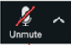
- Click on Test Speaker and microphone (if not working well)
- Click on audio settings to adjust volume
- Click Switch to Phone Audio to use phone and toll-free device

Troubleshooting Tip: If students can’t hear you, they may need to adjust their volume either on their computer, on their head set or in the Zoom session via Mute > Audio Settings
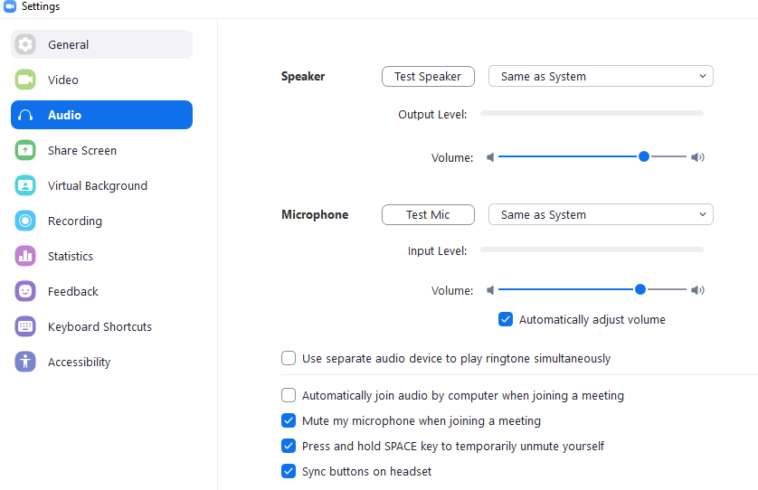

If your students still can’t connect via computer audio, they can switch to Phone Audio and call in toll free.
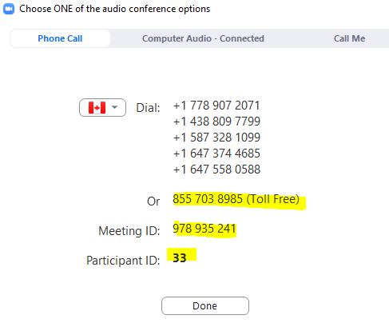
Video: Avoid having all student videos on all of the time in order to ensure a smooth session connection. Have students introduce themselves individually at the start of the session or in small groups within Breakout Rooms where they can turn on their videos. Note: Zoom has a limited number of cameras it can have open at one time.
Invite: You shouldn’t need to use this since; by setting up your meeting within Brightspace, students will automatically be able to access the session. No separate enrolment of students is required.
Manage Participants: All students will have access to various controls and non-verbal feedback icons. This includes the ability for students to raise hands. For full details, visit: Managing Participants in a Meeting
Polling: This tool can be quite inconsistent, and we are advising not to use it for now. If you wish to include polling in your session, try using the free version of Mentimeter. Just share the connection information within the session.
Screen Share: You are able to share specific program files, your entire desktop (which is easier to manage), and a whiteboard for freehand drawing/writing. For full details, visit: Sharing Your Screen (Note: When you share your desktop, be aware of what is on your desktop – close unwanted or confidential programs, turn off automatic pop-up notifications and hide anything you don’t want to be seen).
Chat: All participants are able to send messages either to everyone in the session or privately to individuals. If enabled by you in your account settings, you and students can share files via the chat feature. You can save your session chats.
Record: You can record your sessions and save them to the cloud to have students view later.
Breakout Rooms: With break-out rooms, you can easily allow students to have small group discussions. For more information, visit: Getting Started with Breakout Rooms

