By this point, you have reviewed Checklist 1: Getting Started with Zoom at Algonquin. This means that you now have a Zoom Pro password. You can find all three Zoom checklists on the LTS Tools for Delivery page.
Use this checklist for setting up Virtual Office hours, one-on-one meetings, or small-group meetings. If you are looking to set up regular class meetings, look at Checklist 2: Whole-Class Zoom Sessions through Brightspace.
REVIEW MEETING PERMISSIONS IN YOUR ACCOUNT SETTINGS
- Go to the Algonquin College Zoom portal and sign in.
- Click on Settings.
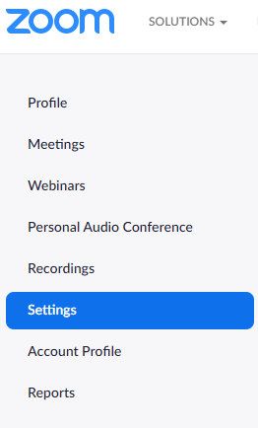
If you are hosting virtual office hours, you may wish to make these permissions active:
- Play sound when participants join or leave to be notified when someone arrives in the session.
- Waiting room has participants wait to be admitted to the meeting. This allows you to see students one at a time.
Other settings you may wish to make active for your meetings include:
- Mute participants upon entry to be notified when someone arrives in the session.
- Waiting room has participants wait to be admitted to the meeting. This allows you to see students one at a time.
- File transfer if you wish to have files shared via chat during the session.
- Non-verbal feedback to allow participants to express non-verbal feedback, raise their hand, or express opinions through icons in the Participant panel.

SCHEDULE YOUR MEETING
Method #1
- Go to the Algonquin College Zoom portal and sign in.
- Click on Schedule a Meeting in the top right on the menu bar.
Method #2
You can also schedule meetings through the Zoom app on your computer.
- Find and launch the Zoom app
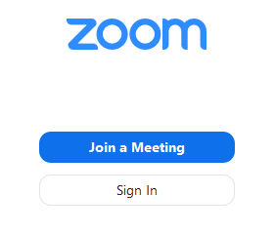
- Click on Home
- Click on Schedule 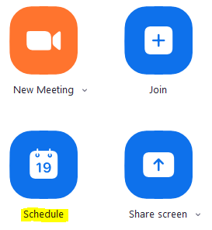

Zoom Session Settings
- Add Topic
Include course name and meeting date in the title so students know which ones to attend on which day. E.g: Wednesday March 25 – GEN1001M Intro to Ethics
- Set the day and time of session. The remaining settings should be as shown below:
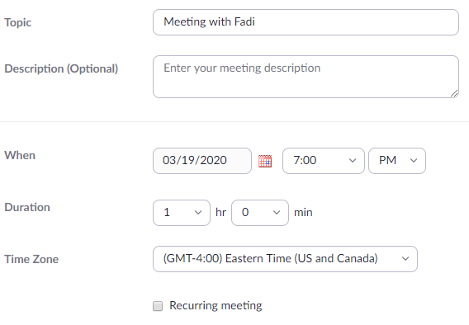

- Check that the remaining settings are as shown (the password is generated automatically):
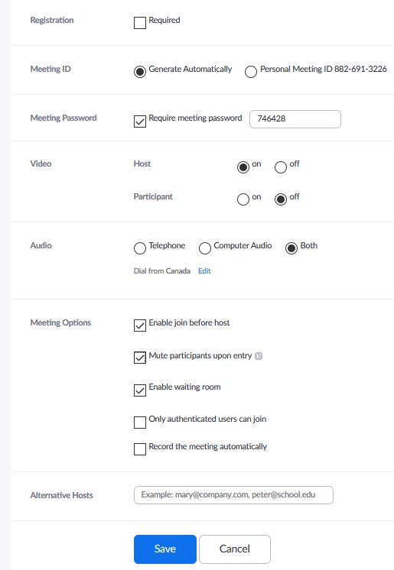

- Scroll up to find the link and password for the meeting, to share with only those students that you would like to participate, using Algonquin College email accounts.

START YOUR MEETING

On the day of your meeting:
- Log into your Zoom account either through the Algonquin College Zoom portal or through the Zoom app on your computer.
- Click on Start Meeting or Join (if you are using the Zoom app).
