Adding and Updating your Presentations information with MyMediaSite

Having clear and relevant descriptions and information associated with your presentation is essential for searchability, generating interest and maximizing the viewers’ experience. This document will show how to update various Presentation Information settings within MyMediasite, select the Algonquin College MyMediasite Player, enable the Questions & Answers option and create a Poll for your presentation.
-----------------------------------
The first step is to open your web browser and login to MyMediasite at https://mediasite.algonquincollege.com/mediasite/mymediasite (using your Algonquin Username and Password).
Next, open the presentation that you would like to update. Pictured below is a screen like what you should see. Please click “Edit Details”.
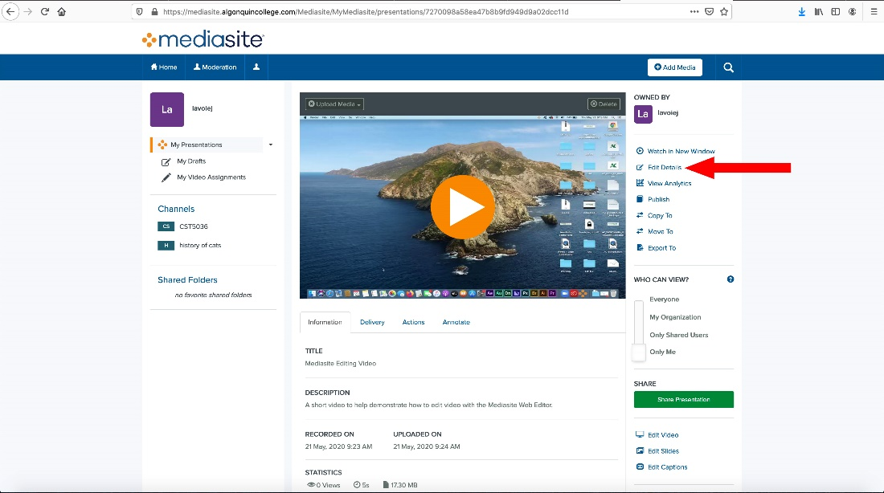
Clicking “Edit Details” will open a new page. There are several areas in this screen that need to be looked at:
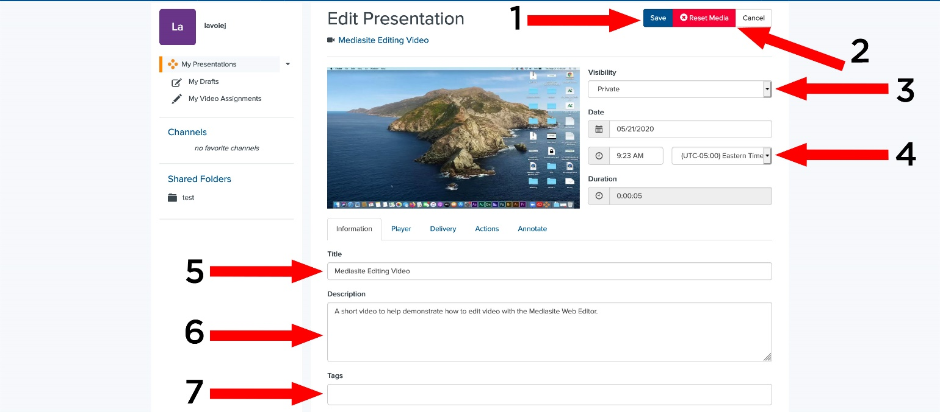
- Save: Any changes that you make to this section will need to be saved by clicking here or on the save button at the bottom of the page.
- Reset Media: Clicking this button will ERASE YOUR PRESENTATION including slides, videos and analytic data.
- Visibility: You can toggle between making your presentation publicly visible, or not, here.
- Date Information: Date and duration information of your presentation.

Information Section:
- Presentation Title: The title of your presentation. Having a clear, concise title (relevant to the subject matter) can help generate interest in your presentation. This area is searchable for information within Mediasite.
- Description: The description for your presentation. This area is searchable for information within Mediasite.
- Tags: Tag information or your presentation. Add tags that describe your presentation to help with searches and your catalog/channel(s).

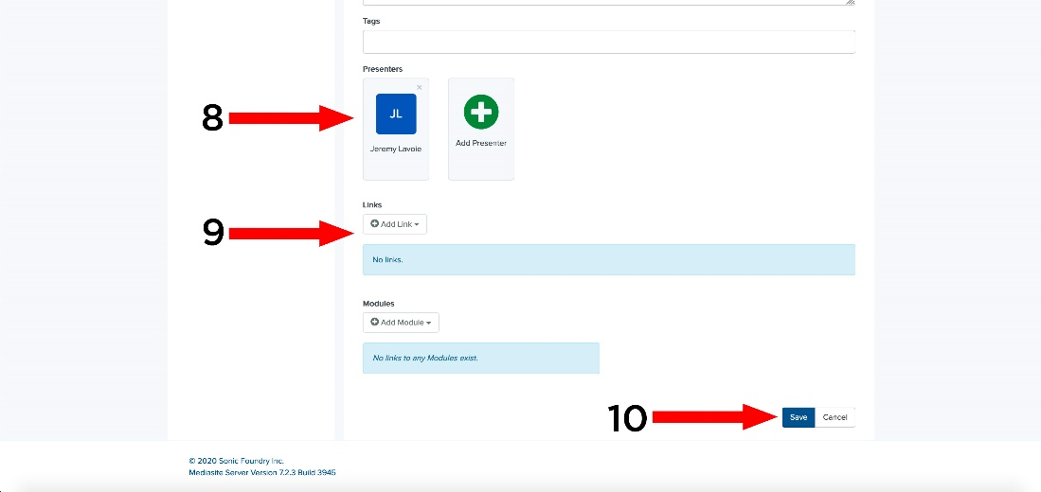

8. Presenters: The people who are presenting in the video. You can both add and delete presenters. To add new presenter, click “Add Presenter” and then find them in the list. If you are unable to find them, you can create a new presenter by clicking on “Create New Presenter”.
This area is searchable for information within Mediasite.
9. Links: In this area you can provide any links that are related to your presentation.
10. Save: Any changes that you make to this section will need to be saved by clicking here or on the save button at the top of the page.

Player Section:
Please click the “Player” tab.
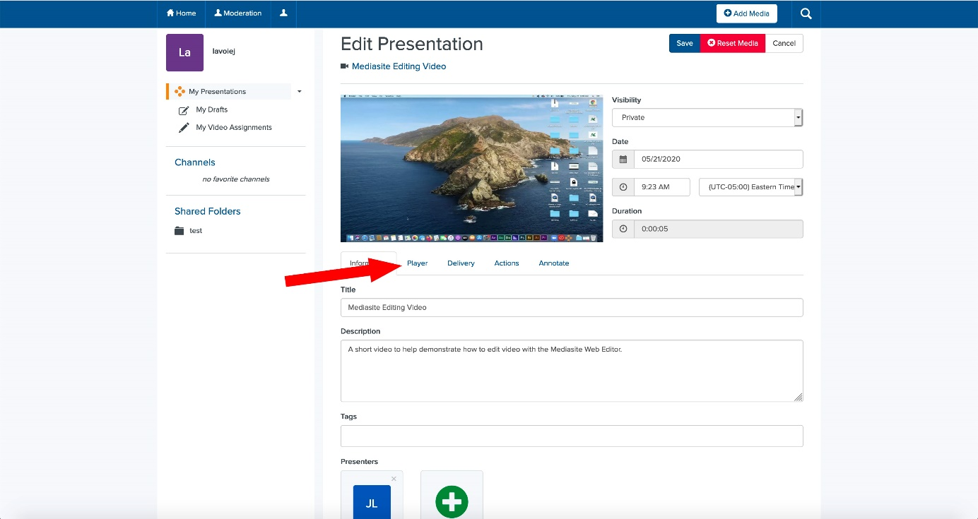
The new screen that is displayed has a lot of options. We are only interested in a few of them however.
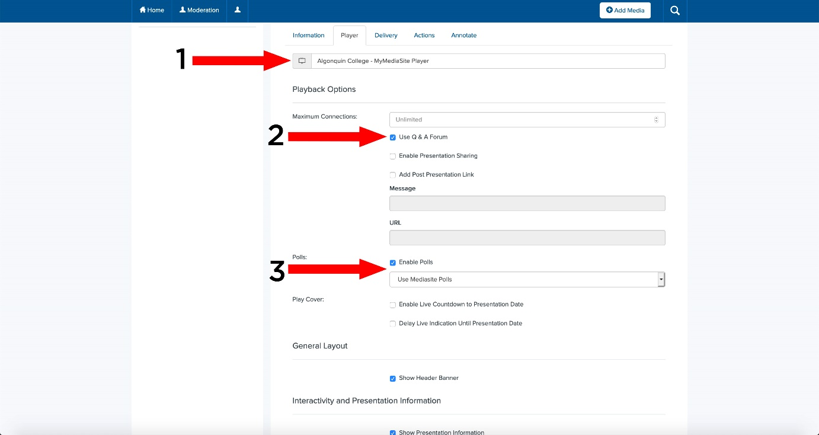
- The Player that will display your presentation. Please select “Algonquin College – MyMediasite Player”
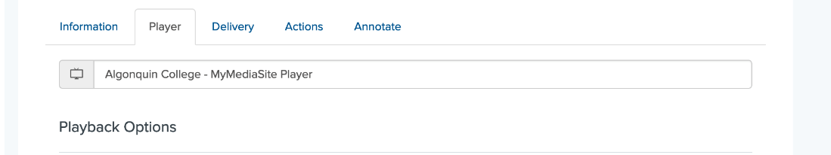
- If you want to enable the Questions and Answers Forum, check the box for this.
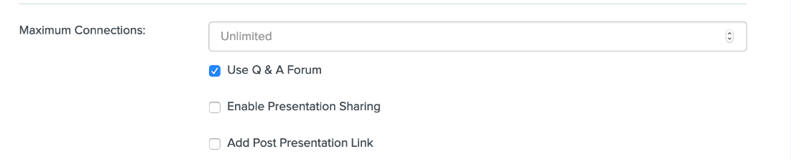
To see if you have questions waiting, you will have to click on “Moderate”, located on the main page in the sidebar menu.
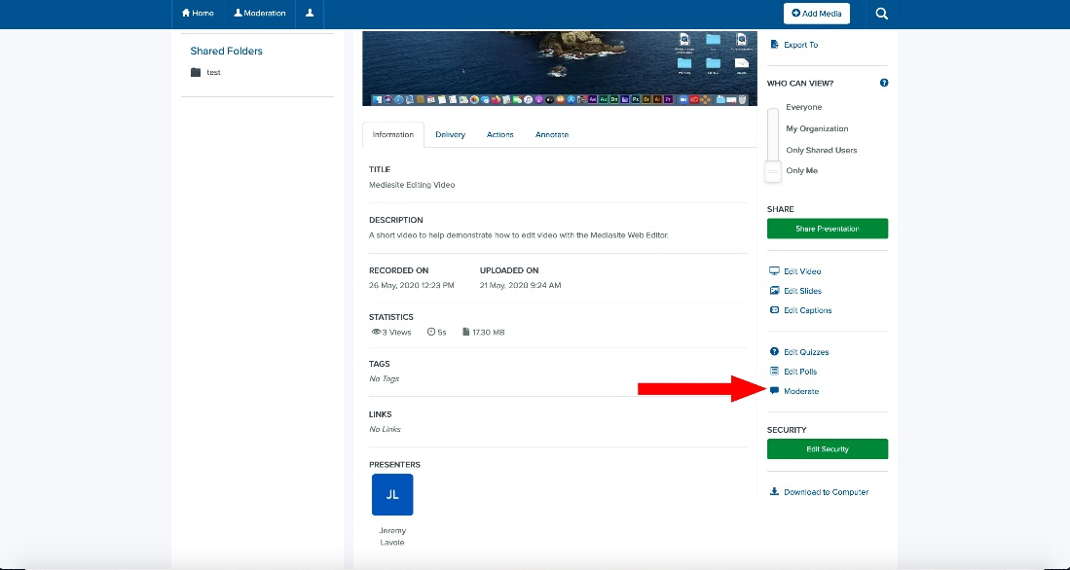
The moderation page will appear. You can see any questions/comments/annotations that have been made on the video here.
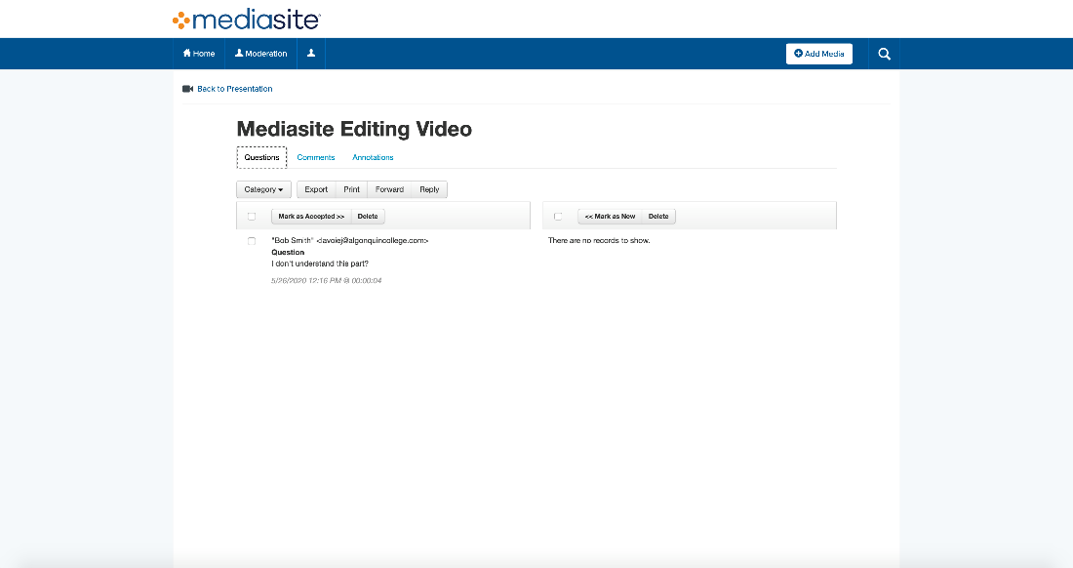
- If you want to enable Polls, check the box to do so.
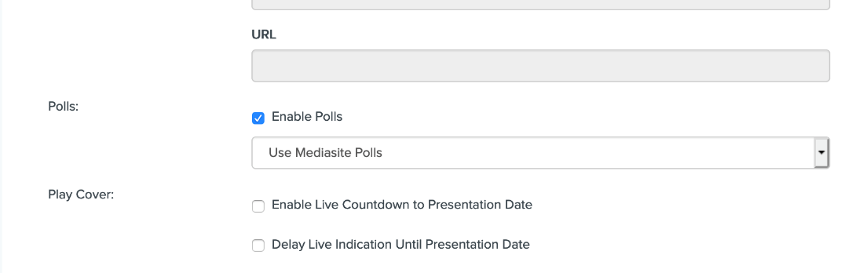
You will also have to create the poll itself, which is located on the main presentation page, pictured below. Please click “Edit Polls”.
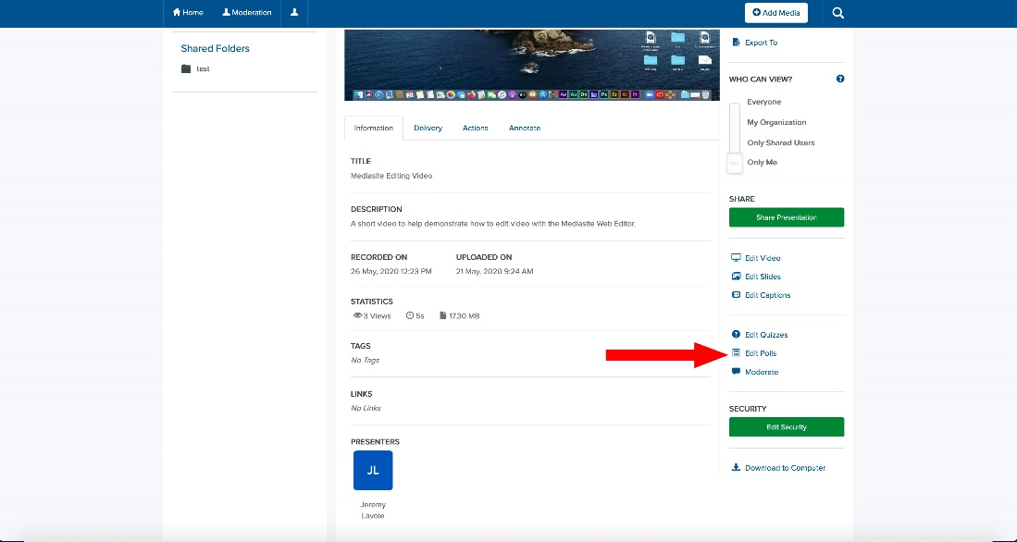
The Poll creation page will pop up. You can use this page to create polls. If you save your poll as a template, you can bring it up across multiple presentations. Remember to save your question!
