This document is to demonstrate how to use the Mediasite Web Editor to edit a video segment, insert a chapter and then create a new video presentation from those edits. A brief description of the components is provided as well.

Starting the editing process:
Once your presentation has finished the upload process, you will see it under the “My Presentations Tab” as shown below, along with any other presentations you have uploaded or scheduled to occur.

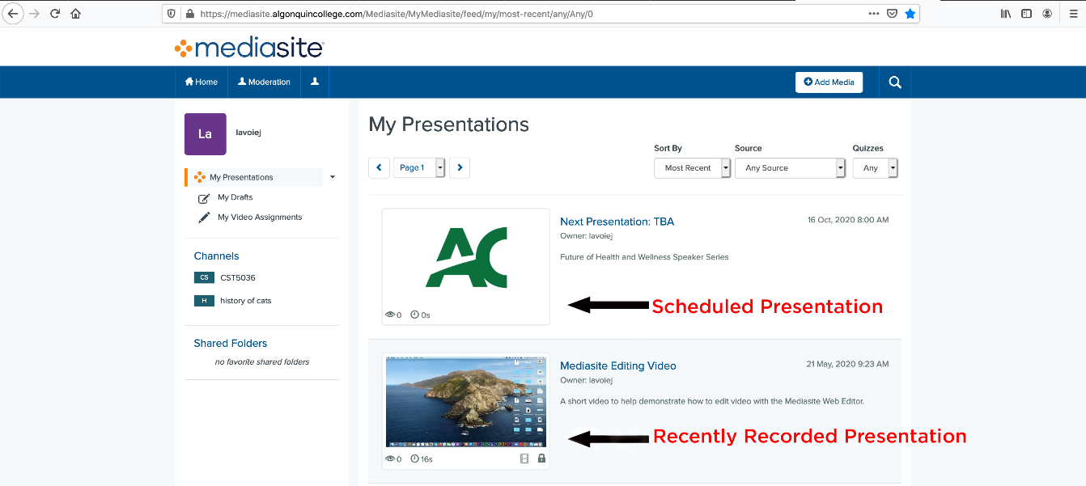
Please click the link to your recently recorded presentation.
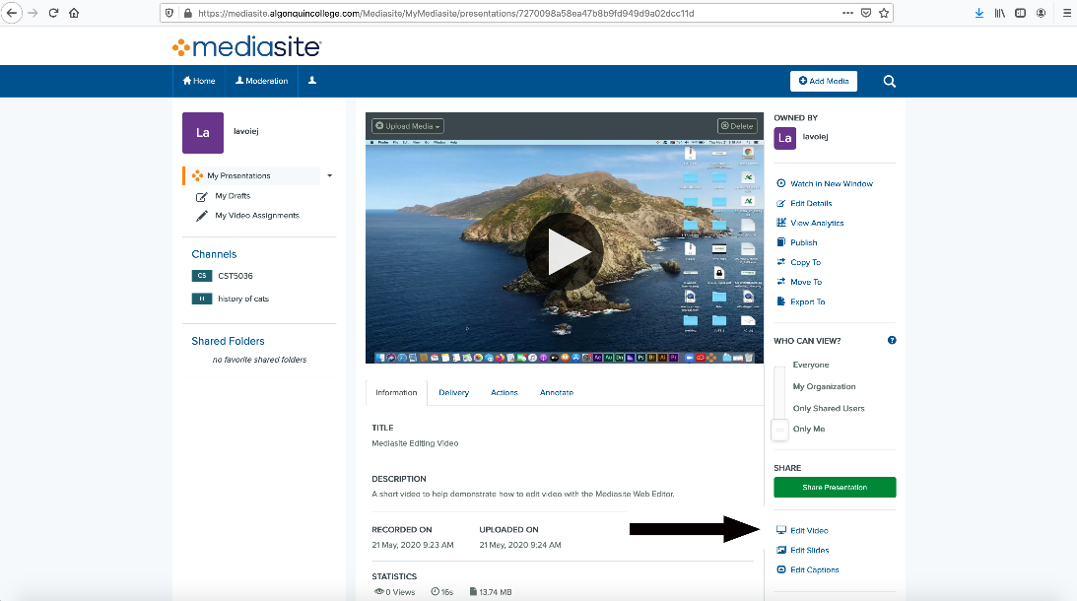
Click “Edit Video” in the sidebar menu. If you do not see the link “Edit Video”, please try again later as the video is still being processed.
A window should open showing the webcam and screencast preview with a timeline. This presentation was set to be a screencast. If you have slides in your presentation, they will show up under the audio waveforms.
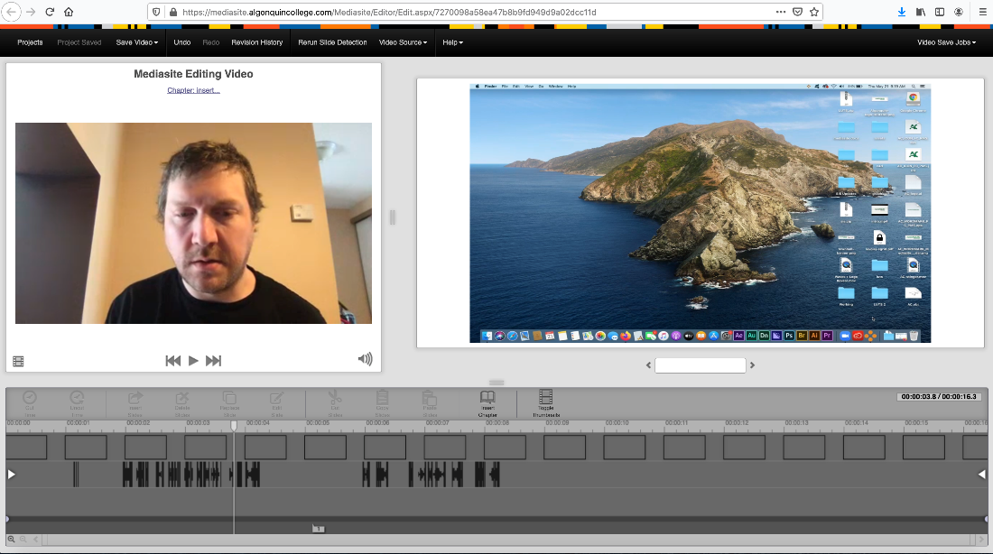
The Web editor has several different areas which are broken down below in separate pictures:
The Top Panel:

Projects: A presentation can have multiple projects associated with it. You can open, copy and delete each of these projects. Each project has a list of changes that you can see (and revert to), within Revision History.

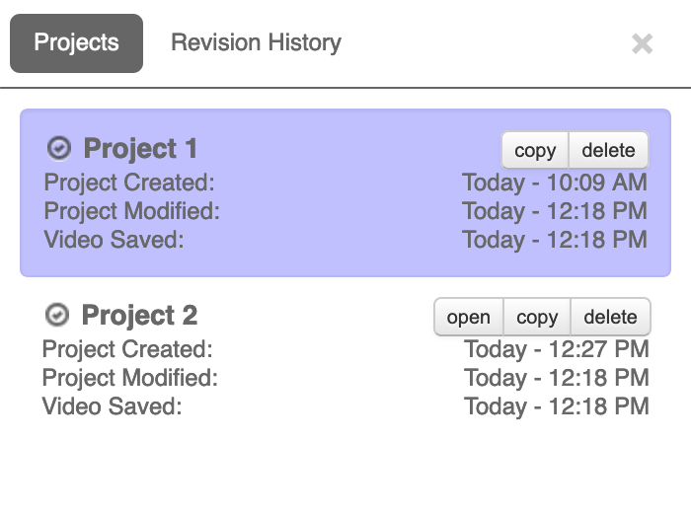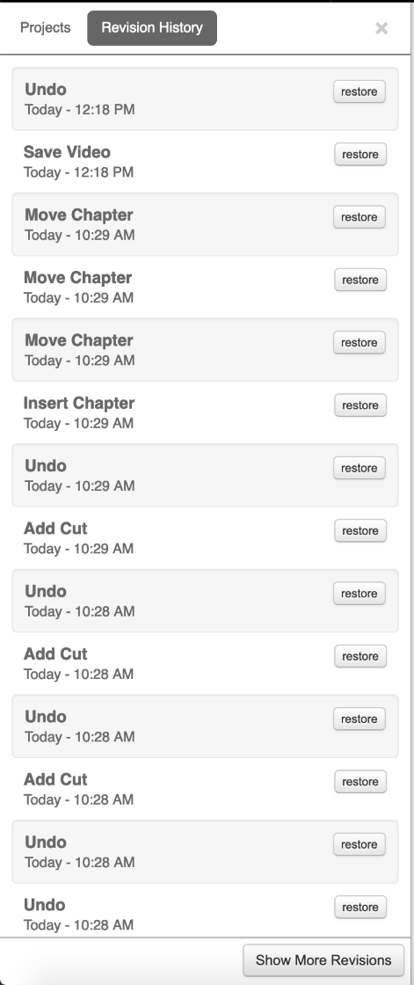

Save Video: You have three options under this drop down menu. Save to Current, Save to New and Save to Existing. It is important to understand the distinctions between these.
- Save to Current: This will save your presentation over the current revision that you are working on. If you wanted to revert to a previous revision, you can do that within the Revision History Panel.
- Save to New: This will create a new presentation on the Mediasite server and you will be asked to provide a name for the new presentation. This will leave a copy of the original presentation on the server.
- Save to Existing: This will overwrite a presentation on the Mediasite server. A box will appear that will ask you to find the presentation to overwrite. This will overwrite both scheduled presentations and presentations that are already residing on the server.

Undo/Redo: Undo and Redo changes to the presentation. You can access a list of revisions from the Revision History Panel.
Revision History: A list of changes that have been made to the current project. You can revert / undo any changes that have been made to the current project by visiting the Revision History panel and selecting “Restore” next to the change that you would like to go back to. A picture of the Revision History box can be found on the previous page.
Rerun Slide Detection: You can use this tool to cut down on the number of duplicate slides that you have in your presentation. A sensitive slide detection setting combined with transitions in Powerpoint can sometimes result in thousands of slides (reducing the amount of duplicate slides will help when it comes time to edit the slides).
Video Source: This option deals with the layout of two areas of the Mediasite Web Editor. The Left Video Preview Area and the Right Video/Slide Preview Area.
- Left (Video+Audio): If you recorded multiple video streams (such as from your webcam and a screencast), you can select which video will be assigned here. If there is only one video stream, it will be shown here in the Left Video Preview Area for you to edit.
- Right: Any number of video streams can be assigned here as well as slides, which will be shown in the Right Video/Slide Preview Area.
Help: Mediasite documentation and support files are available here.
Video Save Jobs: The status of the video(s) after they have been saved (either to new, current, or existing presentations). It may take a while for a video to be completed depending on the file size and the activity on the server.

The Left Video Preview Area:

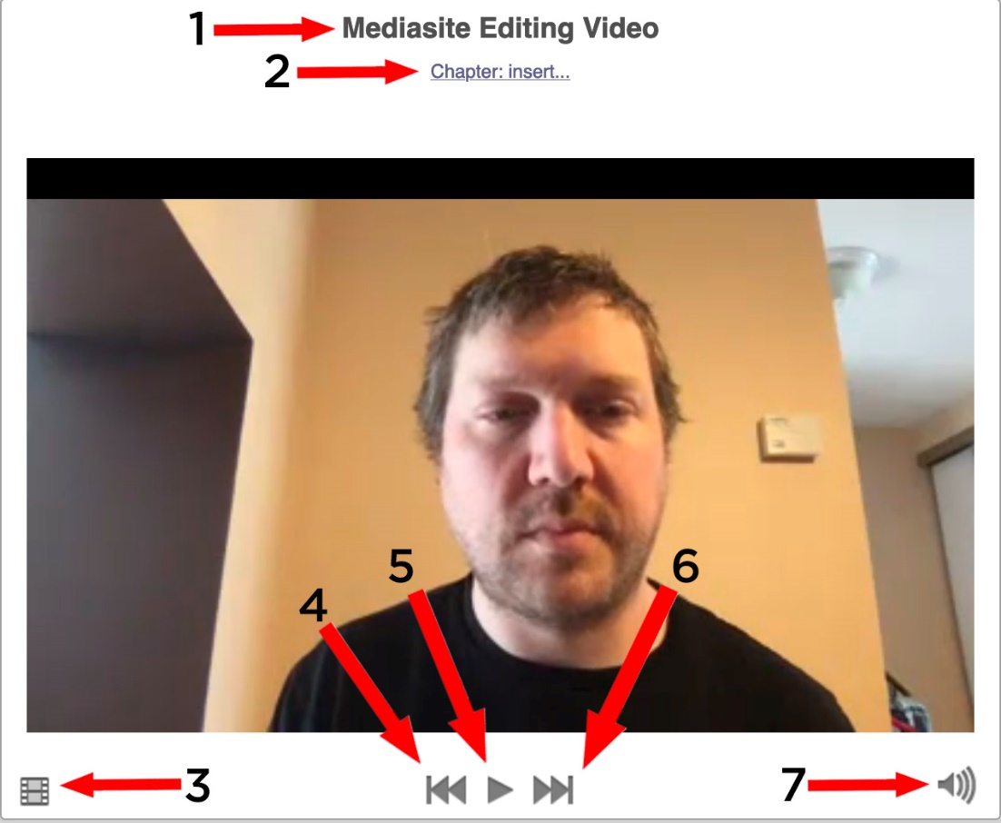
The left video preview area will only display video. If you have multiple video streams in your presentation (such as a screen cast or a document camera), you may select which video stream to preview via the Video Source drop down menu in the Top Panel. This area has several components which are described below.
1: Presentation Name
2: Chapter Name/Insert Chapter
- Chapters are navigation points in a presentation that allow people the ability to jump forward or back. They are easily manipulated just underneath the timeline (please click and drag to move them around). If no chapters are created, the forward and back arrows will restart or end the presentation.
3: Convert Video to Audio Only Stream
- Clicking this button will drop the video from the presentation. The audio stream, slides and any alternate video streams (such as a screen cast or document camera) will not be affected.
4: Previous Chapter
5: Play/Pause Video
6: Next Chapter
7: Mute / Unmute Video

The Right Video/Slide Preview Area:
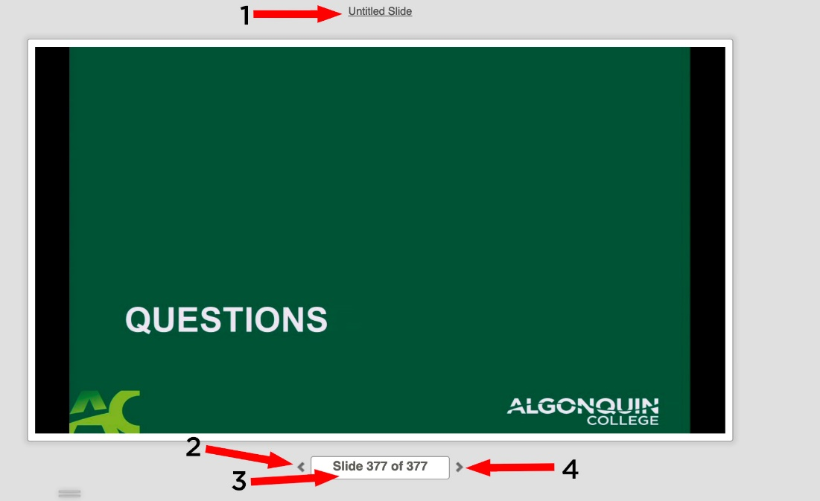
In the Right Video/Slide Preview Area you can display any available video sources, such as a screen cast or document camera, as well as your slides. To switch the video or slides, please click on the Video Sources drop down box located in the Top Panel.
1: Slide Title
- The area will list the title of the slide. To change the title, or add a desciption of the slide, please click here.
2: Previous Slide
3: Slide Count
- Lists the number of slides in the presentation. You can enter a number into this box to skip to that slide.
4: Next Slide

The TimeLine:
Navigation:
The timeline lets you navigate through the presentation. There are ways ways to jump to specific time codes and to resize the timeline for easier editing. They are listed below.
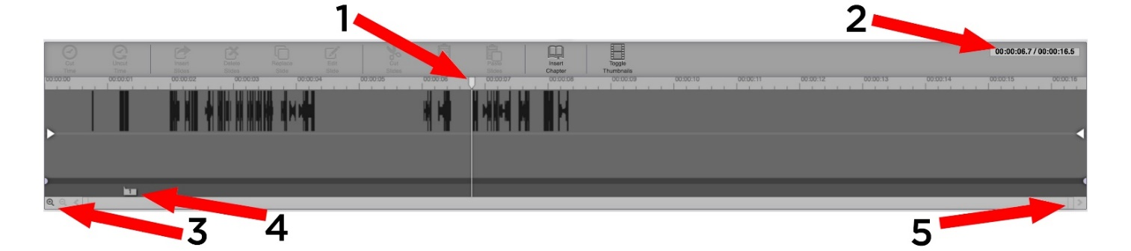
1: Playhead
- Represents the time (or position) along the timeline. You can click along the timeline, drag the Playhead, use the left and right arrows on your keyboard or click and manually enter a timecode in the Time Display to change the Playheads position.
2: Time Display
- The first section of the Time Display denotes the position of the Playhead relative to the timeline. The second sections display the duration of the presentation.
3: Zoom Controls
- Magnify or shrink the timeline (you can use the up or down arrows on the keyboard as well)
4: Chapter Marker
- Chapters indicate points in your presentation that you may want to highlight. You can click and drag the markers along the timeline as well as rename and delete them (by clicking on them). To insert a new chapter marker, position the Playhead on the timeline where you would like the chapter marker to appear and click either the button on the timeline or on the “Insert Chapter” link in the Left Video Preview Area.
5: Horizontal Scroll Bar
- Allows you to scroll left and right across the timeline. You can also zoom in and out by clicking and dragging on it.

Adding Cuts, Dissolves and Fades to your video and understanding the difference of each (and when/why to use them)
(Tip: You might find it easier to get your precise selection if you zoom in/out!)
Using cuts, dissolves and fades is important for the video aspect of your presentation for a number of reasons. They not only help to clean up videos in terms of getting rid of dead air but can also help to provide a storytelling element, and to keep tempo (Think of how “fast” a video seems which has a lot of cuts eg: Action as opposed to a video that does not – documentaries).
Cuts:
A cut will “remove” that section of the audio/video from the presentation. When you preview/publish the video, it will appear as if that section has been removed. A cut is non-permanent and can be lengthened or shortened.
To perform a cut, click and drag the Playhead across the timeline for the length of time that you would like to cut, and either hit ‘c’ on the keyboard or click the “Cut Time” button on the Timeline.
1: Selection Handle
- To delete a Cut, click the selection handle at the top of the cut and select delete or you can pull the selection handle to either the beginning or the end of the Timeline. You also click on the selection handle to change the Cut to either a Fade or a Dissolve.
2: Audio Waveforms
- Audio Waveforms show where in the video the microphone has recorded audio. They are useful to show where there is a lot of dead air in the video (you may want to remove it to shorten the length of the video)
3: Cut Handle
- Drag the Cut Handle to modify the length of the cut. (Tip: Zooming in and out may help!)
4: Fade Handle
- A cut can be modified into a Fade by clicking on the Fade handle and dragging either left or right into the video.

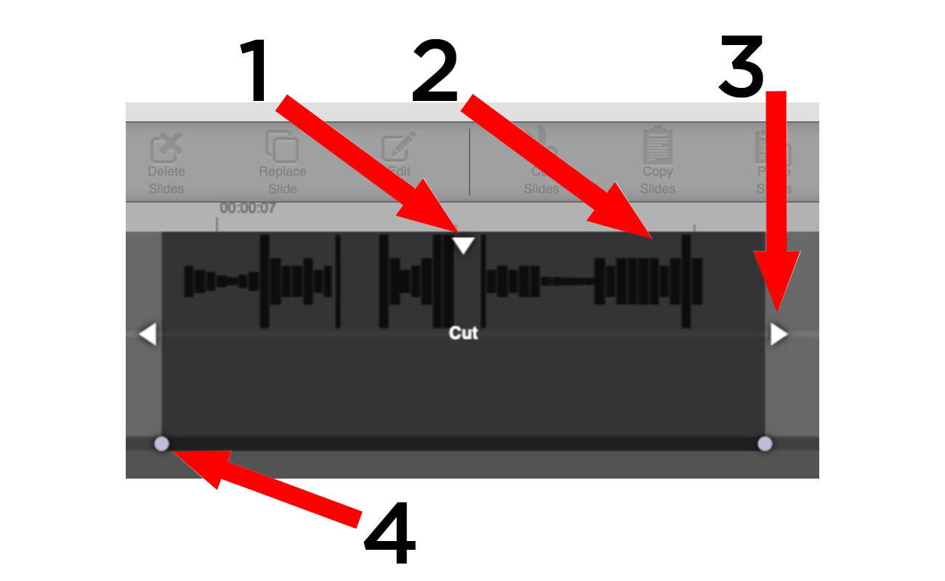

Fades:
Fades are gradual transitions to and from black that removes/mutes a section of the audio/video stream. It is non-permanent and can be modified with the Fade Handles. The rate of fade can be different at the start and the end of the cut.
To add a Fade, click and drag the Playhead across the Timeline and create a selection. Hit the “f” key on the keyboard.
- 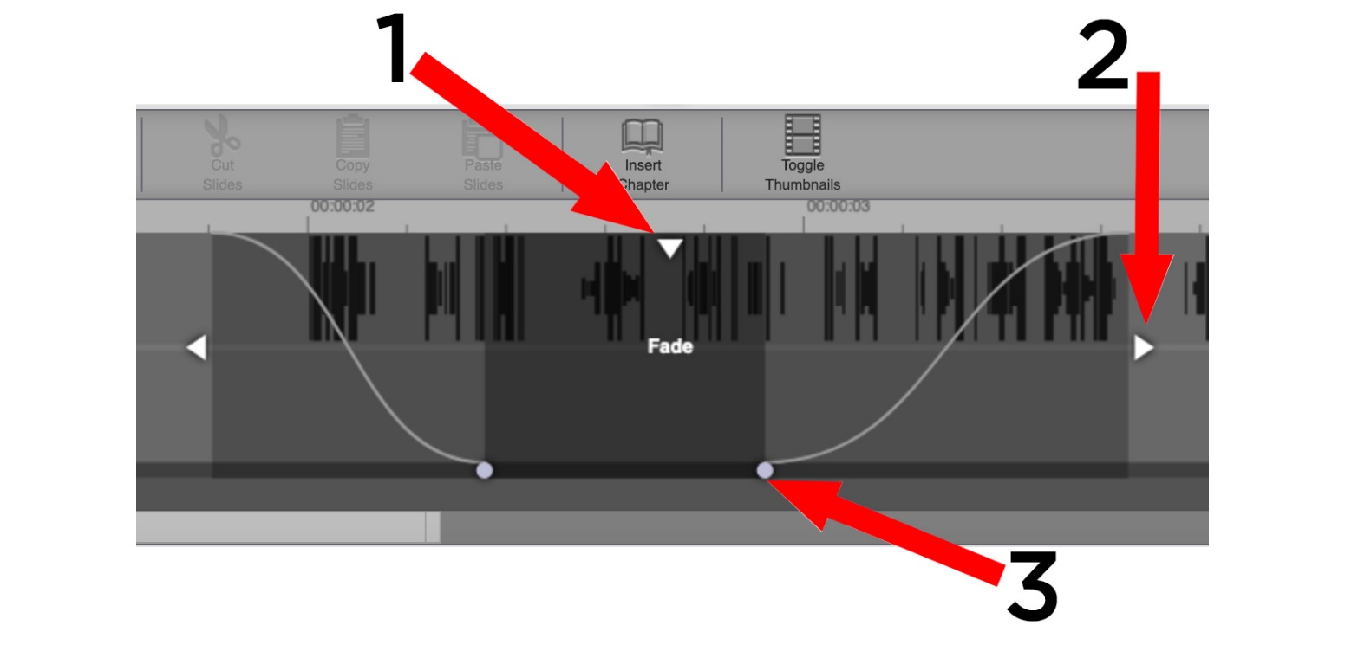1: Selection Handle
- Click and drag on the selection handle to move a Fade
- To delete a Fade, click the selection handle at the top of the Fade and select delete (or you can pull the selection handle to either the beginning or the end of the Timeline).
- You can also click on the selection handle to change the Fade to either a Cut or a Dissolve.
2: Cut Handle
- Drag this left or right to modify the length of the Fade. (Tip: Zooming in and out may help!)
3: Fade Handle
- Drag the Fade Handles left or right to determine the length of time that the Fade occurs over. The curves (rate of fade) can be different at the start of the cut and at the end.

Dissolves:
Dissolves smoothly fade the video in or out of the cut. It is non-permanent and can be modified with the Dissolve Handles. The rate of fade is the same on both sides of the cut.

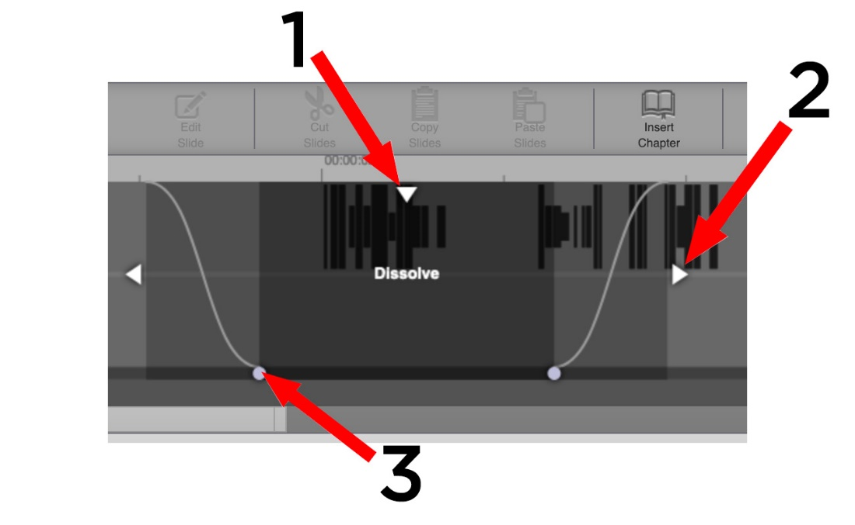

1: Selection Handle
- Click and drag on the Selection Handle to move a Dissolve
- To delete a Dissolve, click the selection handle at the top of the Dissolve and select delete (or you can pull the selection handle to either the beginning or the end of the Timeline. )
- You also click on the selection handle to change the Dissolve to either a Cut or a Fade.
2: Cut Handle
- Drag this left or right to modify the length of the Dissolve. (Tip: Zooming in and out may help!)
3: Dissolve Handle
- Drag the Dissolve Handles left or right to determine the length of time that the Dissolve occurs over. The curves will be the same at the start and the end of the cut.

Editing the Video:
1: Set the video sources for your presentation from the Video Sources dropdown menu located in the Top Panel (if you recorded more than two you may have to specify which goes to the right or left preview window. The right window will always have slides).
2: Look at the audio waveforms. Are there large segments where they are absent? In the picture below, I will need to trim down the end of this presentation. I can do that by dragging the selection handle from the right side of the timeline towards the left. I can add a fade (1 second tends to be nice) by using the fade handle to the end and I will add a fade to the beginning as well.
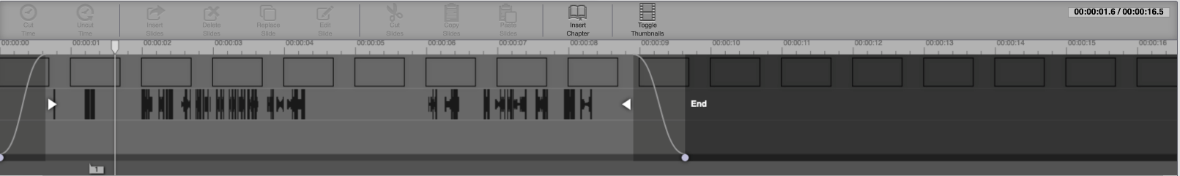Do the areas in the middle of the timeline need to be cut? Click or drag the playhead to the area in the middle of the presentation where there is no audio and preview the video (press spacebar on the keyboard or click the play button on the Left Video Preview Screen) and press ‘c’ on the keyboard (or “f for a Fade and ‘d’ for a dissolve), or click where it says “Cut Time” on the timeline (You might find it helpful to zoom in when making the selection/using the cut handles). It’s a good idea to play through your cuts to make sure that everything looks good
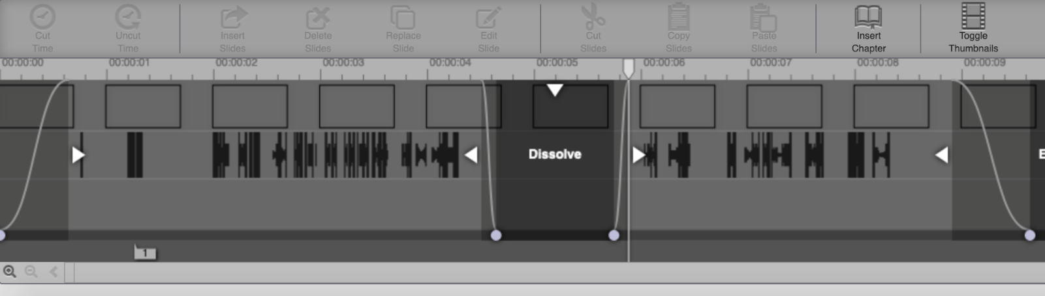
3: Do you want to add chapter(s) to your presentation? Chapters are points in your presentations that you want to draw attention to. To create a chapter, position the Playhead on the timeline to where you want the Chapter Marker to be and click ”Insert Chapter” on the Timeline. A prompt will appear asking you to name the chapter, followed by a marker below the Playhead.
4: Save your presentation by clicking the Save Video dropdown menu (located in the Top Panel), and selecting one of the three saving options.
- Save to Current: This will save your presentation over the current copy (revision) that you are working on. If you wanted to revert to a previous revision, you can do that within the Revision History Panel.
- Save to New: This will create a new presentation on the Mediasite server and you will be asked to provide a name for the new presentation. This will leave a copy of the original presentation on the server.
- Save to Existing: This will overwrite a presentation on the Mediasite server. A box will appear that will ask you to find the presentation to overwrite. This will overwrite both scheduled presentations and presentations that are already residing on the server.
5: Your video will start processing. You can view the progress by clicking on the Video Save Jobs dropdown menu (located in the Top Panel), please be aware that video processing may take some time to occur.
Once your presentation is processing you can close the Web Editor (or start another edit).

