Editing Slides on the MyMediasite Timeline
Slides are an important part of a presentation and there’s nothing worse than having to record a video again because you noticed an error in your PowerPoint slides. This document will demonstrate how to enable the slide server and then insert, delete, replace, cut, copy and move slides along the Timeline. We will also discuss using the Slide Detection Tool to cut down on excessive duplicate slides and using the Slide Edit tool to insert information that can be read by screen readers.

Enabling the Slides Server:
If you didn’t record slides with your presentation, it’s not difficult to put them in after the fact. You will have to enable the Slide Server by clicking on the “Edit Slides” button on your presentations page.
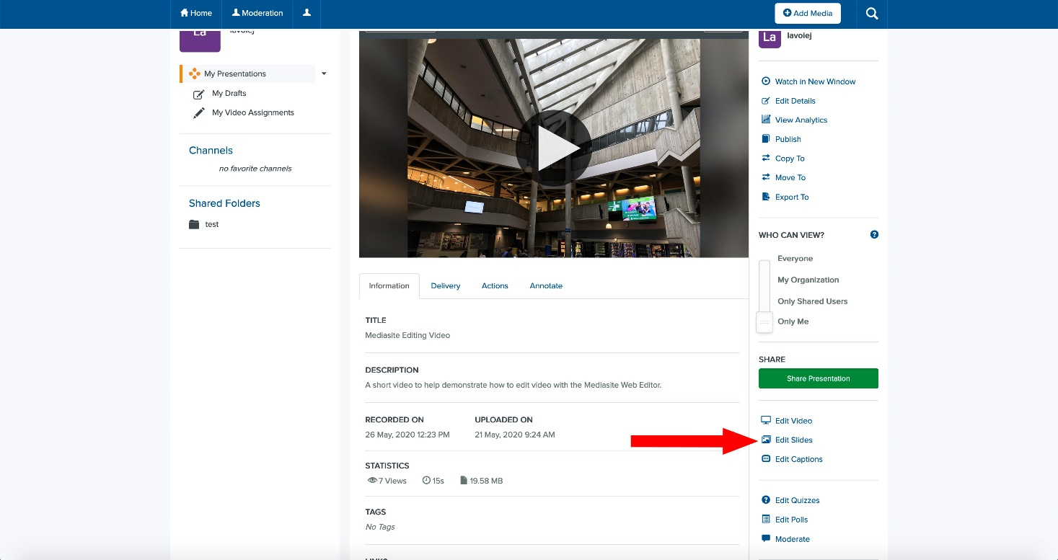
A window will Pop Up, asking if you want to enable the Slides Server. Please click “Enable Slides”.
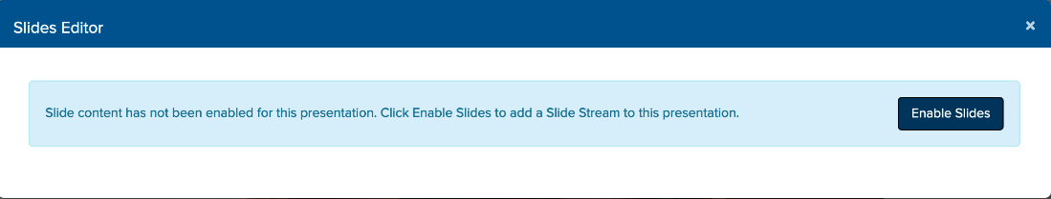

After clicking, a new window will Pop Up stating that there is no slide content for this presentation and to use the Web Editor to add slides. Please click “Open Editor”.
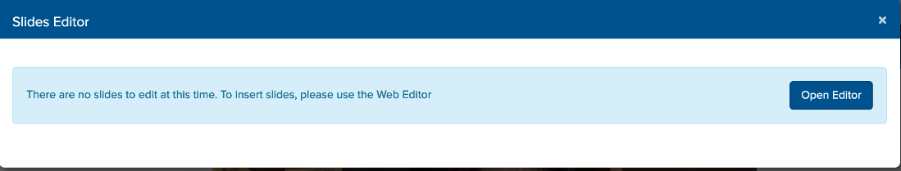

Using the Web Editor to Work with Slides on the Timeline:
The Mediasite Web Editor has a few easy tools to manipulate slides along the Timeline. It is worth noting that it may make things easier if you zoom in / out to precisely position a slide on the TimeLine. To move slides, click and drag them along the timeline (to move multiple slides, hold down shift on the keyboard and click on the slides). If you feel that you may have too many slides to edit (which can be caused by PowerPoints having a very sensitive slide detection rate and there are transitions on the presentation), please go to the Rerun Slide Detection Section.
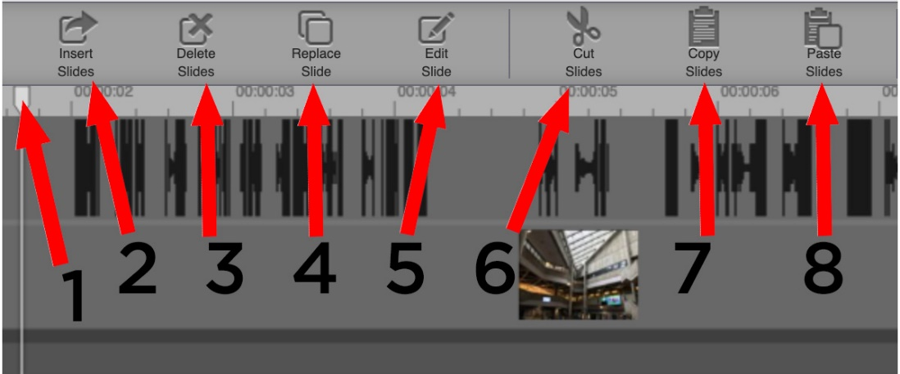
- The Playhead: To insert slides drag the Playhead to the position on the Timeline and where slide is to be placed and then click “insert Slides”
- Insert Slides: Click here to insert slides into your presentation, a dialog box will open and you will be asked to select a file (Tip: You can select multiple files at once to speed up this process!) . The Slides Server will have to be enabled for this button to work. You can upload the following file types as slides into your presentation: jpg and png.
- Delete Slides: Select the slide or slides you want to remove on the timeline. Click here to remove the selected slides.
- Replace Slide: Select the slide you wish to replace on the Timeline. Click here to open a dialog box asking what slide they should be replaced with. You can’t replace multiple slides at once.
- Edit Slide: Clicking this button with open the “Edit Slide” dialog box. You will be asked to provide both a title and description for your slide. This information can be read by screen readers and will help our staff and learners who are visually impaired.
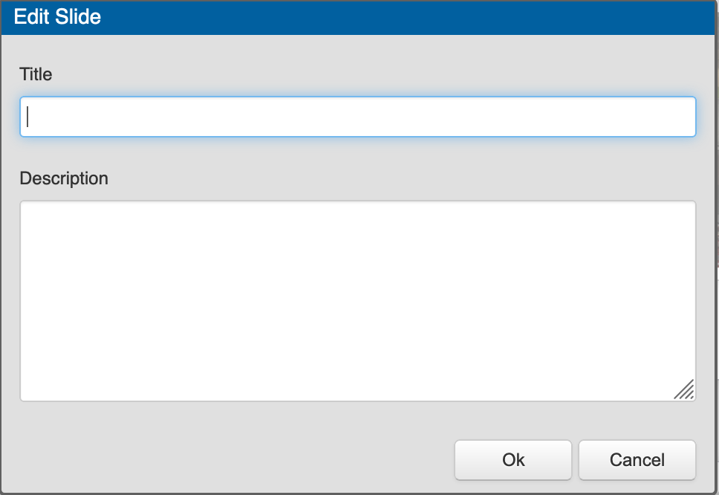
- Cut Slides: Select a slide by clicking on it (to select multiple slides, hold down the shift key on the keyboard) and then click here to remove it from the Timeline. To paste the slide(s), click on Paste Slides.
- Copy Slides: Select a slide by clicking on it (to select multiple slides, hold down the shift key on the keyboard) and then click here to copy it. To paste the slide, click on Paste Slides.
- Paste Slides: To use this tool, position the Playhead on the Timeline to where you would like the slide(s) to appear. And, after using either the “Copy Slides” or “Cut Slides”, click this button.

Rerun Slide Detection:
If you find that you have too many slides (thousands), rather than editing them out on the Timeline, using the Rerun Slide Detection tool can save you some time and get you back on track to fine tuning your presentation.
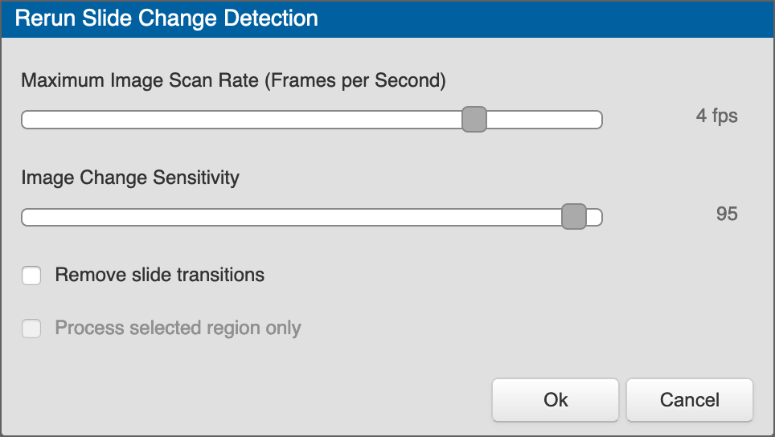
To use the tool, lower both the slider bars and then click ok. You may have to do this a few times and/or lower the slider bars significantly to remove a great deal of slides at once. You can select a section of slides on the timeline and then use the ReRun Slide Detection tool. Using this method you will notice that the “Process selected region only” checkbox is checked by default.
This tool can be found in the Top Panel of the Web Editor:

