Sharing Presentations in My Mediasite
This document will demonstrate how to share presentations with the Share Presentation Button within My Mediasite.

Share Presentation (button):
While it is easy enough to simply go into your presentation, copy and paste the URL in the address bar and send it to someone, Mediasite has a built-in tool to extend your reach. Clicking the “Share Presentation” button, can help you to quickly distribute your presentation by Role, Registered Users and more.
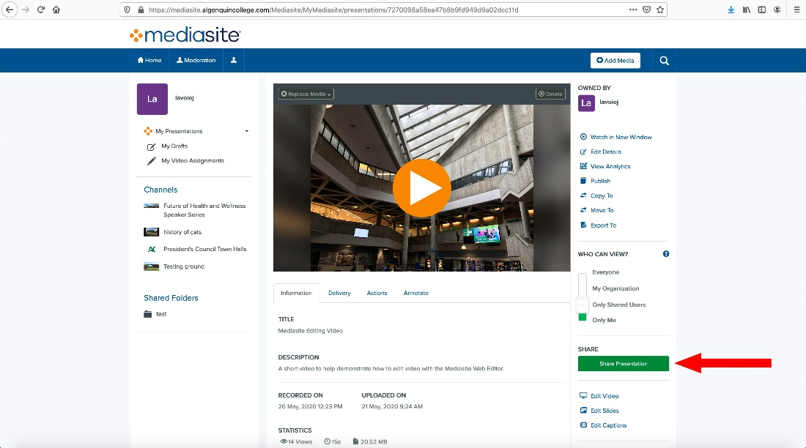
The “Share Presentation” window has four tabs in it and will always display at the top a URL to your presentation. The tabs are as follows: Invite Registered Mediasite Users, Invite Registered Roles, Invite by Email and Embed.

Invite Registered Mediasite Users:
This tab allows you to send an email invite to people within Algonquin so that they can watch your presentation.
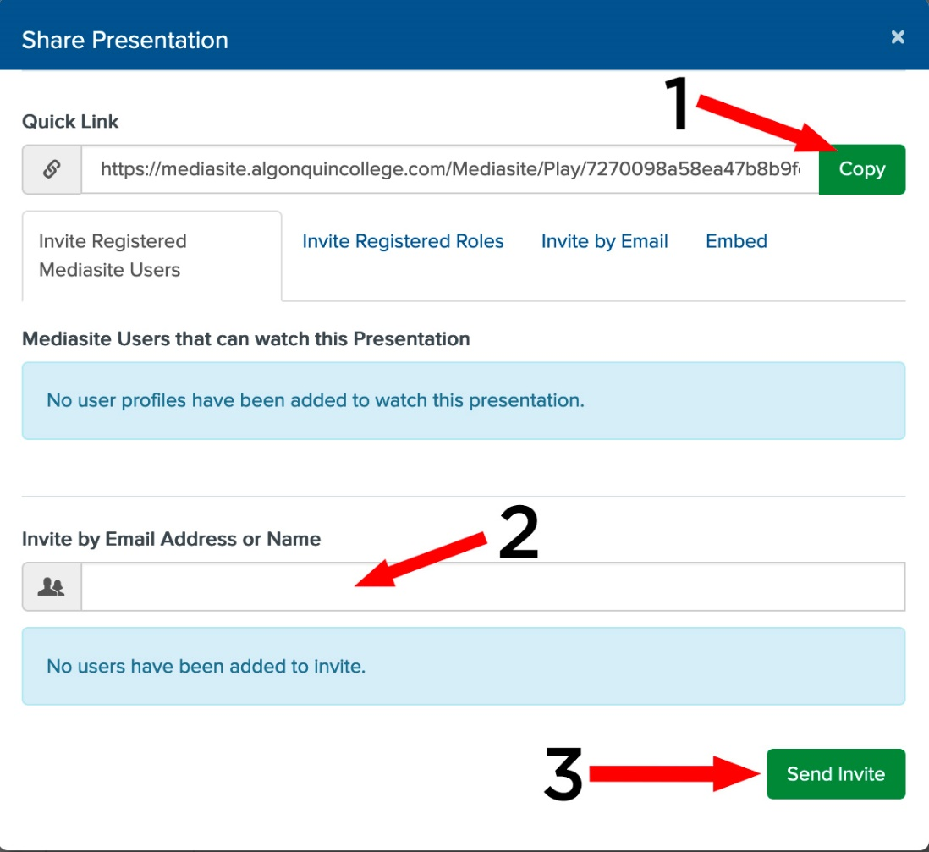
1: Copy – Click this button to have the URL copied to the clipboard so that you can paste it elsewhere later.
2: Invite by Email Address or Name – Fill in the names or email addresses of the people that you want to invite to view your presentation. A list will appear below this bar with the people that you have added.
3: Send Invite - Sends an email invitation with a link to your presentation to all the people that were added via (2). After you click this button, a list of the people who were emailed will be displayed under where is says “Mediasite Users that can watch this Presentation”.

Invite Registered Roles:
Roles are groups of users that have certain permissions granted to them (See the document “Sharing your Presentation in MyMediasite using Channels” for reference on how to modify permissions). The Invite Registered Roles tab allows you to share your presentation with those groups. Please contact the Service Desk if you would like to inquire about having a group created.

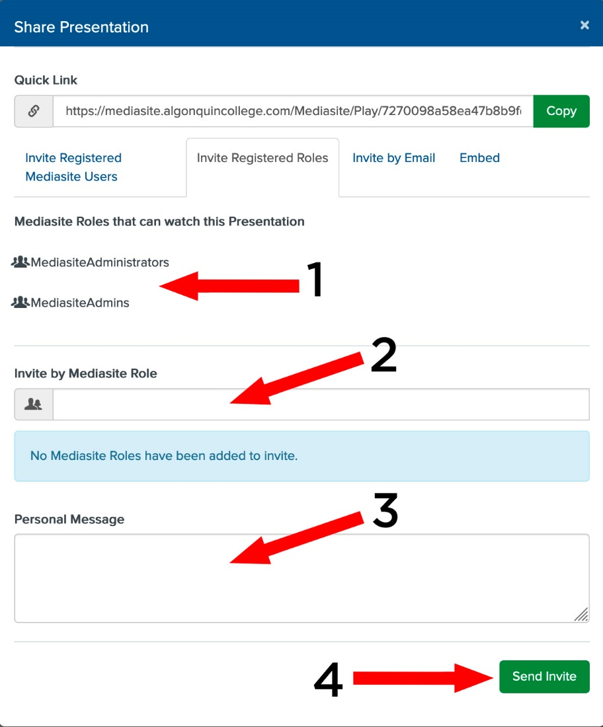
1: Lists the Roles that have access to watch the presentation.
2: Invite by Mediasite Role - Fill in the Roles/Groups that you want to invite to view your presentation. A list will appear below this bar with the people that you have added.
3: In this area you can write a message that will be sent out with the link to your presentation.
4: Click here to send the invite to watch your presentation. After you click here, the Roles/Groups that were invited will be added to the list (1) of Roles that can watch your presentation.

Invite by Email:
This tab will allow you to email people a link and a message inviting them to watch your presentation. This window will also display if your presentations permission settings are set to allow Anonymous or Staff/Faculty/Student (also called Authenticated Users) access.

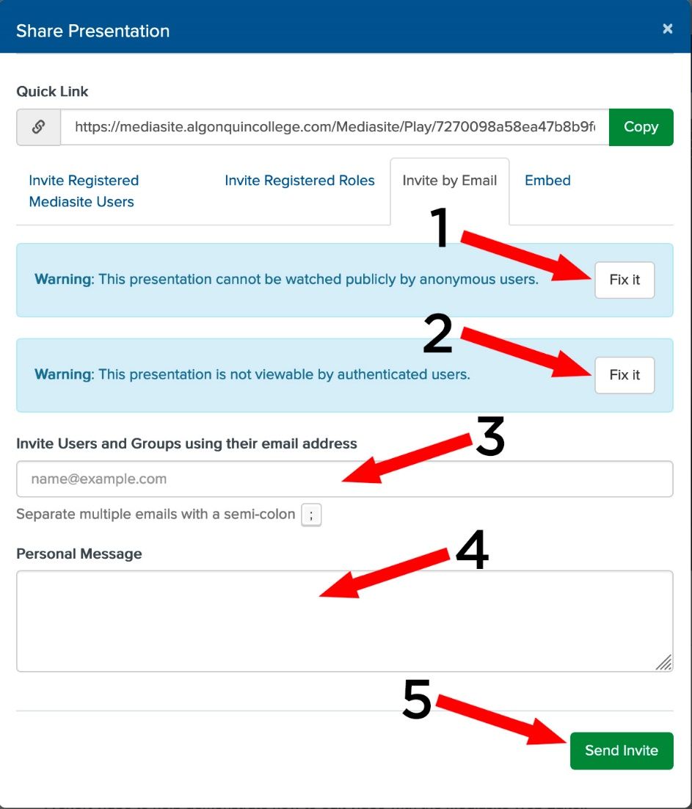
1: Click here to change the presentations permissions so that Anonymous Users can watch it
2: Click here so that anybody with an Algonquin login can watch the presentation.
3: Add the names or email address(es) of people who you would like to invite to watch the presentation. Please separate each email address with a semi-colon.
4. In this area you can write a message that will be sent out with the link to your presentation.
5. Click here to send the invite(s) to watch your presentation.

Embed:
The embed window will provide you with the HTML snippet that you can add to a website so that the presentation is embedded in it. There is an option provided for the size of the presentation: Small 450X300, Medium 900X600, Large 1350X900 and custom.

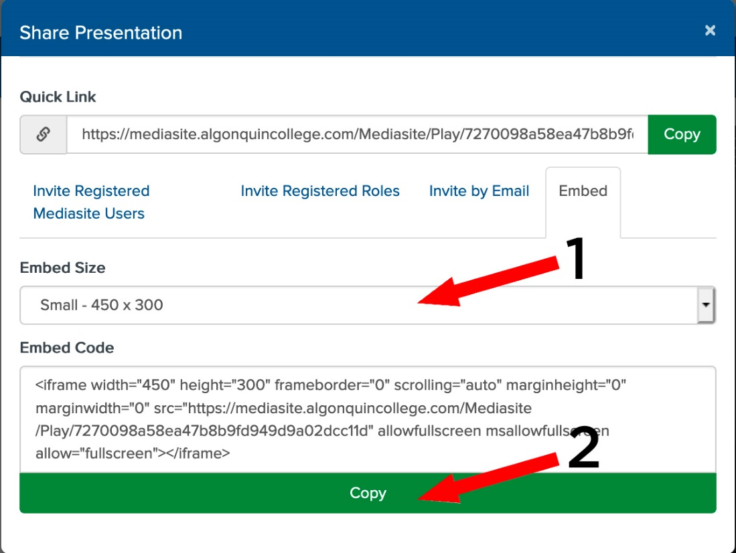
1: Embed Size – This is a dropdown box that lets you select the size of the embedded video.
2. Click the “Copy” button to copy the HTML snippet to your clipboard.

