Sharing your Presentation in MyMediasite using Channels
This document will demonstrate how to use and manage Channels to organize and share your presentations with colleagues and learners.

Channels:
Channels are searchable video collections that allow for comments, time-based annotations, and continuous playback of the channel’s presentations. To access the channels that you have access to, or create a new channel, click where it says “Channels”.
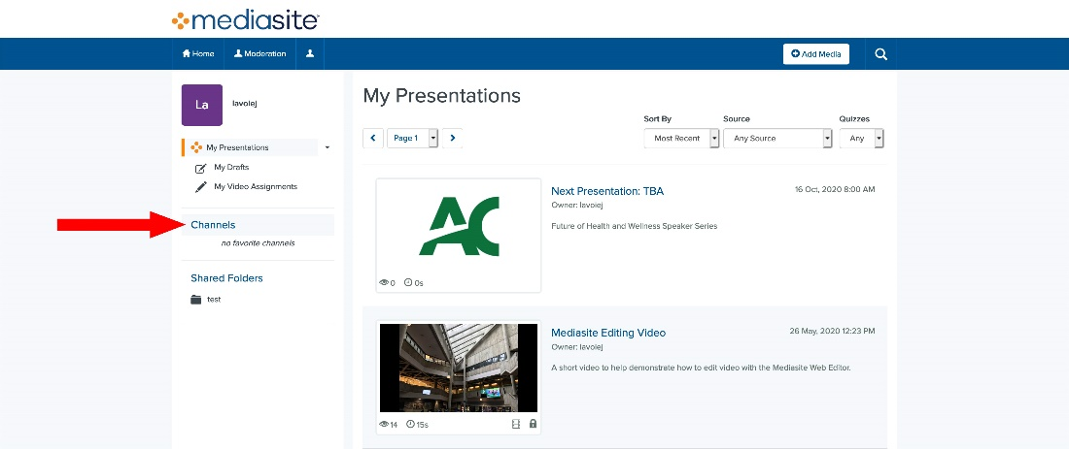
A Browse Channels page will appear. Based upon what the filter is set to, different content will be displayed.
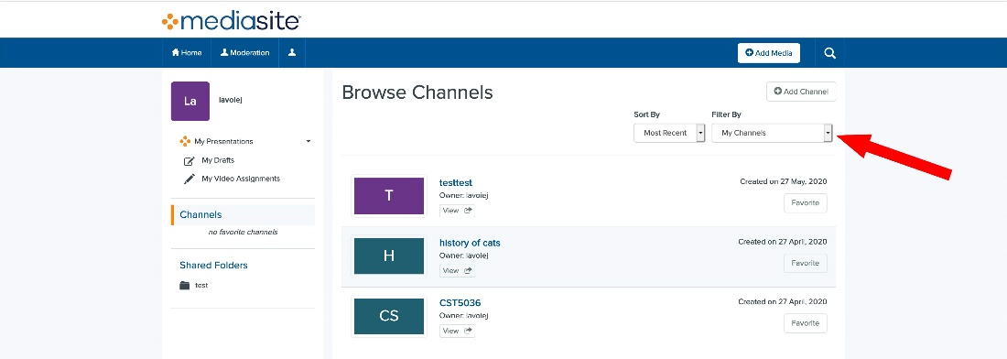
My Channels: This filter will display channels that you have created.
Channels Shared with me: This filter will display channels that have been shared with you. Depending on the permissions, you may be able to edit these videos.
Other Channels I can view: Displays other channels that you have view permissions on. You can’t edit these presentations.

Adding Channels as Favourites:
To add a channel as a Favourite and have it listed on your Channels list (2) is very easy. In the Browse Channels Page, click where it says (1) “Favorite”. Adding favourites allows you quick access to channels that you would frequently like to visit.
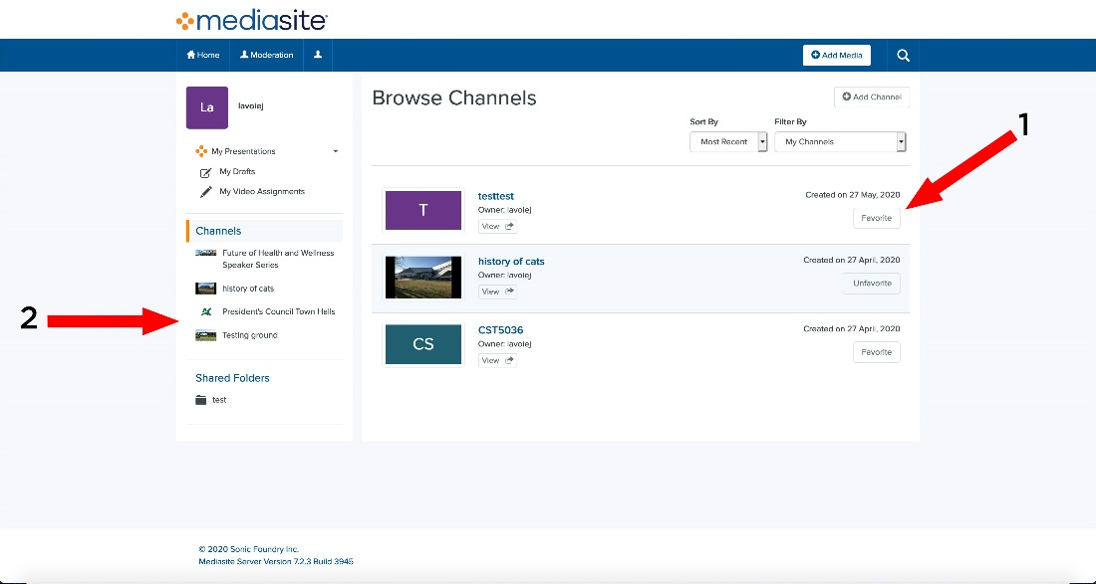

Creating a new Channel:
Please click “Add Channel”, to open the Create a New Channel page.
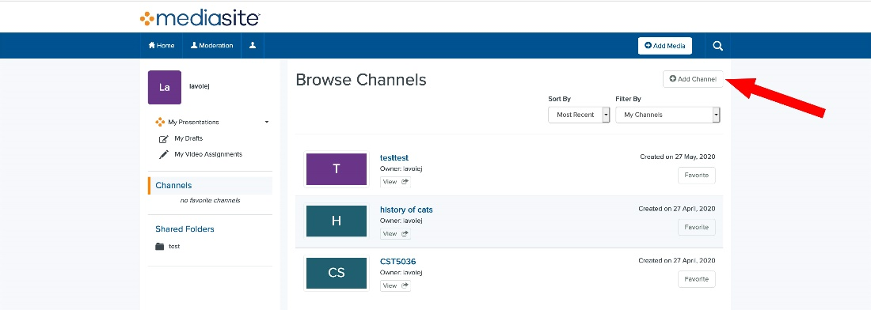
From the Create a New Channel page you can edit a few options.
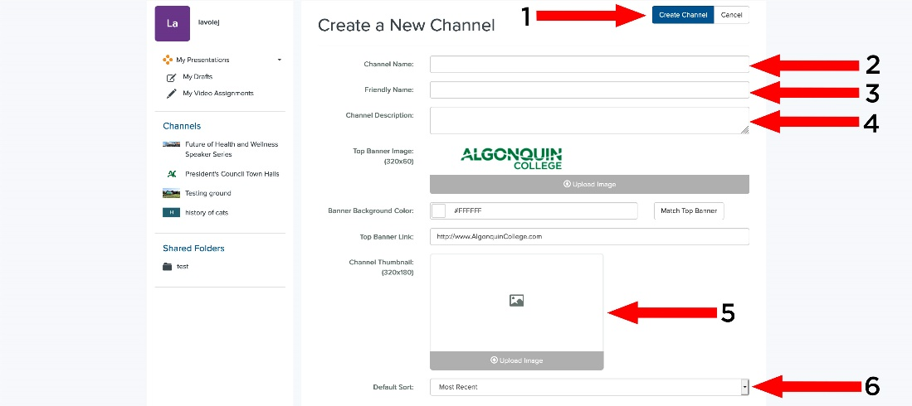

1: Create Channel – Click here after you input the channels information, it will create the channel on the Mediasite server.
2: Channel Name - The name that will appear at the top of the channel, this should be descriptive or be related to the subject matter of the presentations so that people will know what it is when they see it.
3. Friendly Name The name that will appear in the address bar for your channel. For example, the Friendly Name for the Future of Health and Wellness Speaker Series is “hle”.

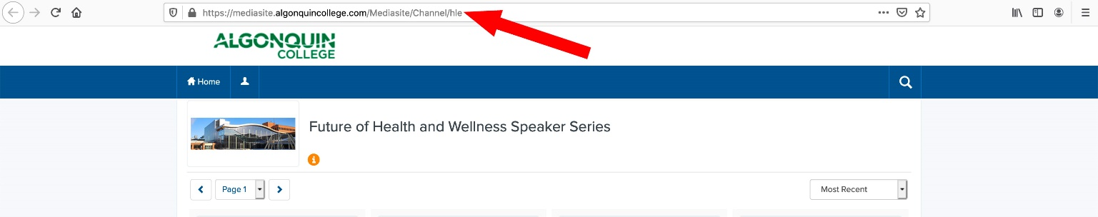4: Channel Description – The Channel Description is displayed at the top of the Channel page by clicking on the little yellow icon. The channel description should be as clear/concise as possible to help viewers determine what the channel is about.
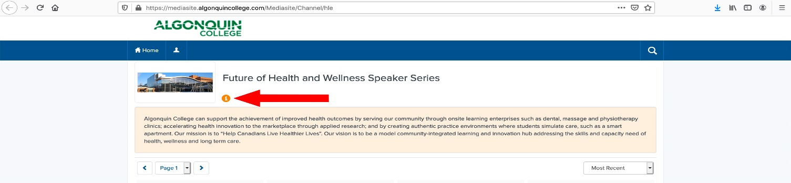
5. Channel Thumbnail - The picture that will show up besides the Channel Name when the Channel is shown, displayed in a Channel listing, or in a person’s favourites list. You do not have to upload a channel thumbnail for a channel to be created, although it is recommended. The maximum size of the thumbnail will be 320X180 pixels (you can upload any size file though) and the following media formats are accepted: jpg and png.
6. Default Sort – In what order the presentations will appear on your channel by default. The following options are available: Most Recent (to oldest), Oldest (to most recent), Title A-Z (Alphabetical).

Moving Presentations into your Channels:
After creating your channel, you probably want to put some content into it. Please open the presentation that you would like to move into your channel and click “Move to” (Pictured Below).
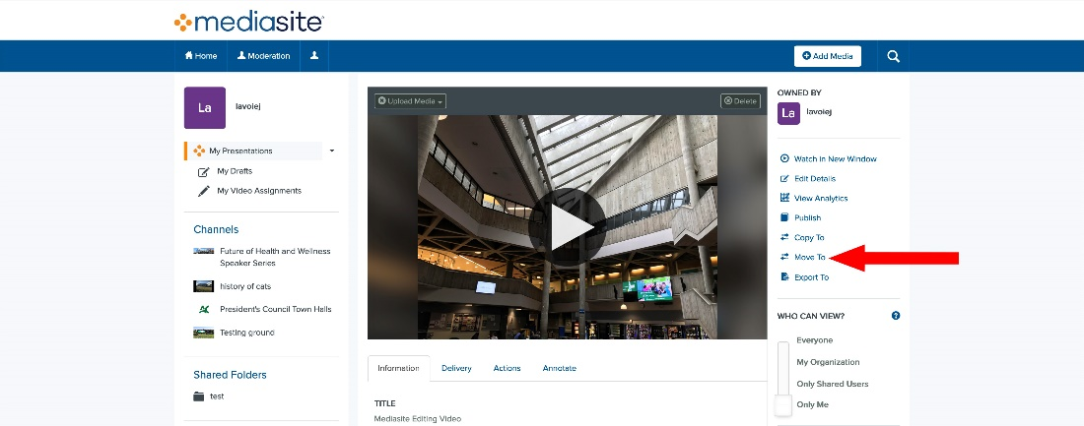
The Move To dialog box will pop up.
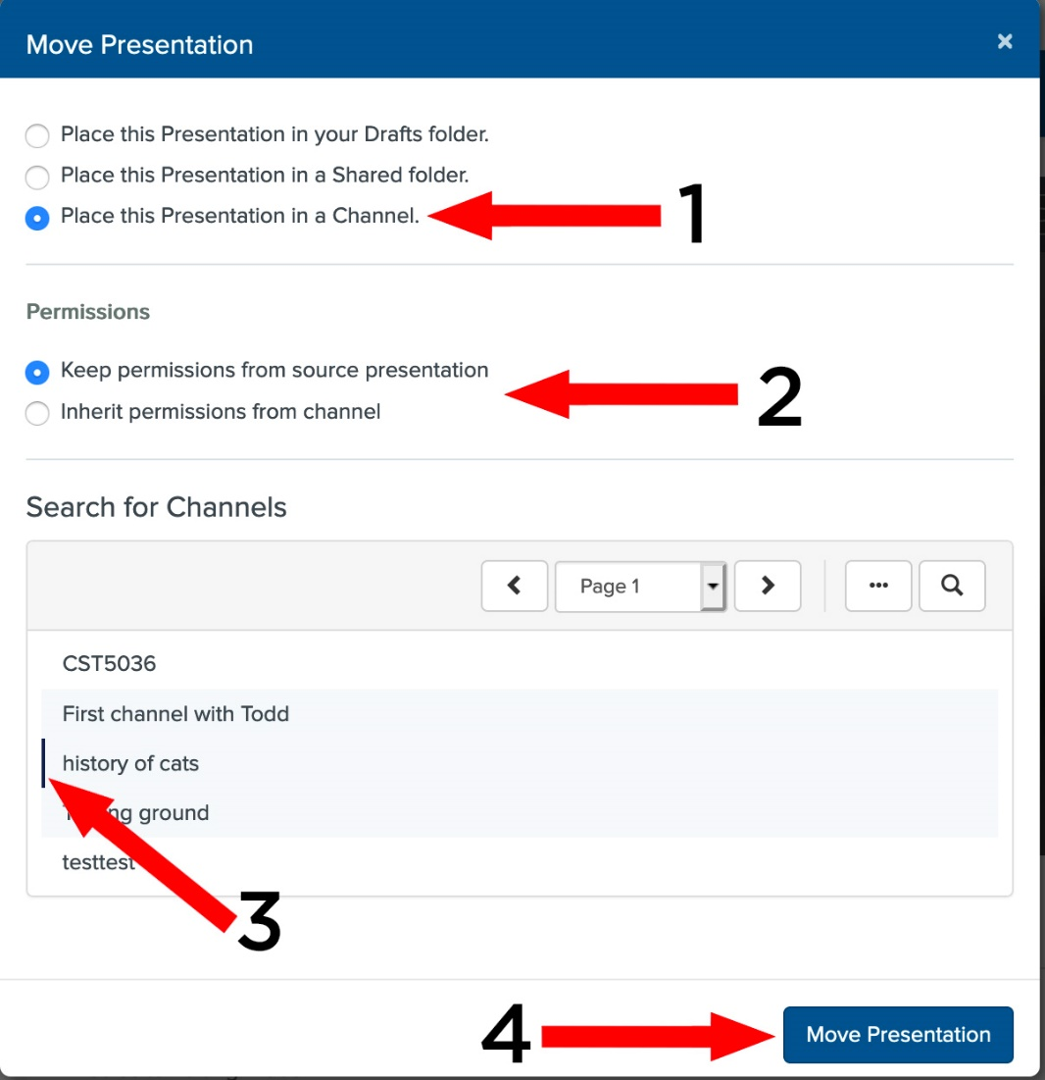
- Please click: “Place this Presentation in a Channel”.
- This section asks whether you want to change the permissions of who can view/edit this presentation to the same as to who can view/edit the channel. Channels have a separate permission list of users and roles separate from the presentations. Permissions and user/roles are discussed below in the next section.
- Search for Channels: This area will fill with Channels that you can move your presentation to. You can click on the magnifying glass to search for a Channel Name or you can go through the list. Once you have found (and clicked) on the channel, a line will appear beside the Channel Name.
- Once you have selected the Channel to move your presentation into, click “Move Presentation”.

Managing your Channel (and Presentations) with Permissions:
Managing your channel (and your content in that channel) primarily consists of making sure that the people who need to edit presentations can, those who need to see the presentations do and determining if anybody else needs access.
Above, in the “Move To” dialog box, we came across a section labelled Permissions, this is a good starting point because it is important to note that both individual presentations and Channels have permissions assigned to them.
The box below is asking the question if the Read / Write and View permissions from the Channel that you are placing the presentation into should overwrite the permissions set on the presentation. It is important to understand what this could mean to people trying to view your presentation. The channel that you are moving the presentation into very well may have group(s) specified that won’t be able to see the presentation unless the presentation inherits the permissions. However, you may have set permissions specifically for this presentation (user whom you have added) and do not want them to be overwrote. The question as always is, who needs to edit, who needs to see the presentation and is there anybody else that needs to be included.
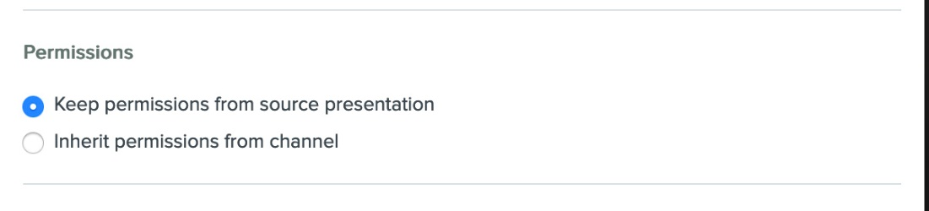

Channel Permissions:
Once you have created your channel, please go into it and click “Security”.
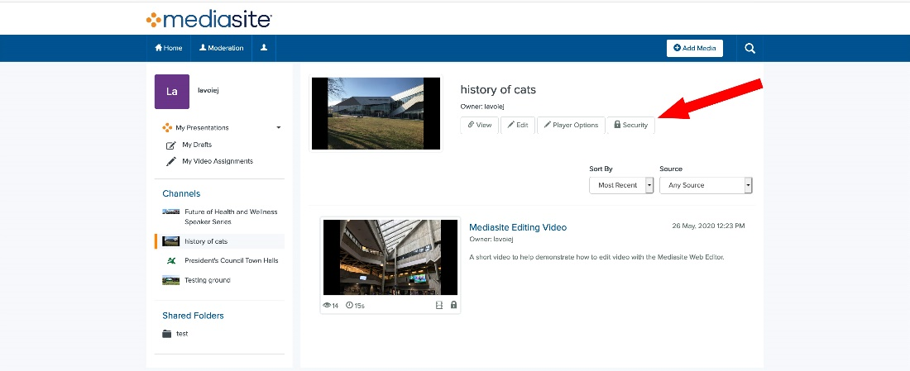
The security dialog box will Pop up.
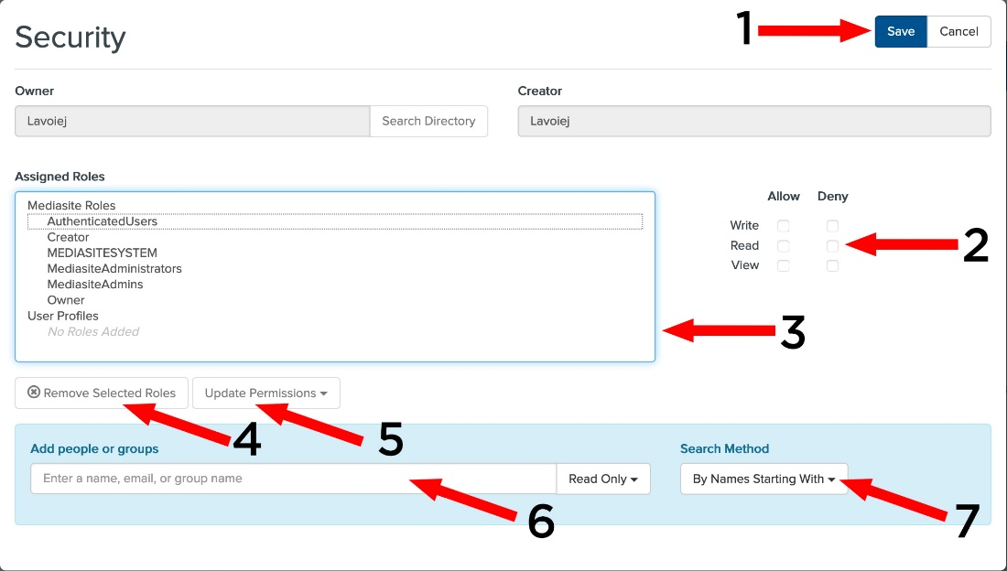
1: Save – Click here after you update the Channel’s permissions for them to happen.
2: Channel Permissions – Click allow or deny, to specify if the User (or Role) can:
Write – User (or Role) can update the Channels settings.
Read – User (or Role) can see that the Channel exists. They will not be able to see the channels content.
View – User (or Role) can see the Channel and its contents. User (or Role) is also able to launch presentations and watch them.
3: Assigned Roles - The list of User/Roles and Groups that are either Allowed or Denied the permission to Read / Write and View the Channel and its contents. To have Groups made (and people added to them), please contact your MediaSite Administrator.
4: Remove Selected Roles – Clicking on a User/Role/Group in the Assigned Roles box and then clicking here will remove them from the list.
5: Update Permissions: This button will change the Channel permission settings for the user/role/group that is selected in the Assigned Roles box. It will not set multiple sets of permissions at one.
6: Add people or Groups: You can add Users and Groups to the Assigned Roles box here. You can determine the starting permissions with the dropdown box to the right of the search box.
7: Search Method: Determines the search method to find Users and/or Groups. You can either search “By Names starting with” or “By Names Containing”.

Presentation Permissions:
To change the Permissions for a Presentation, please click where it says “Edit Security“.
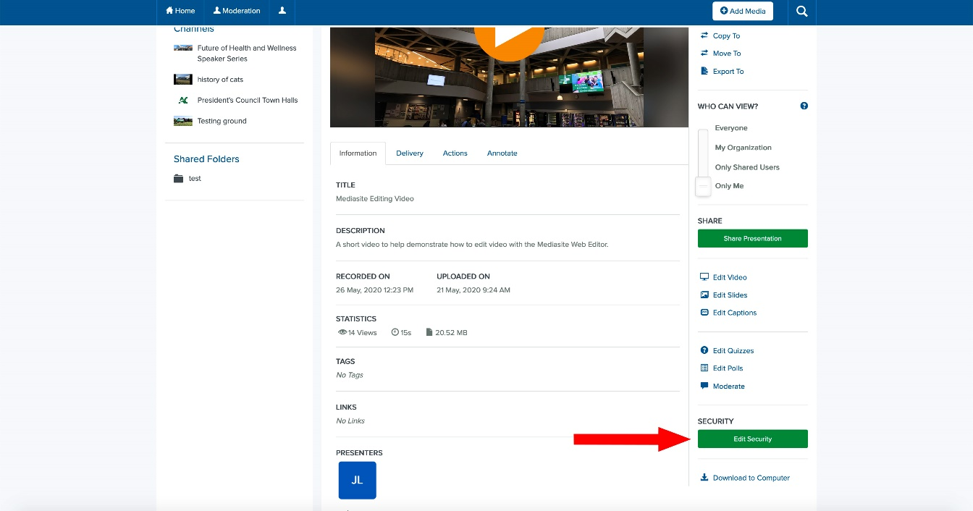
Presentation permissions act the same as Channel permissions and apply to the individual presentation itself. There are a few more options then the Channel permissions (Moderate, Approve, Annotate) which will be discussed below.
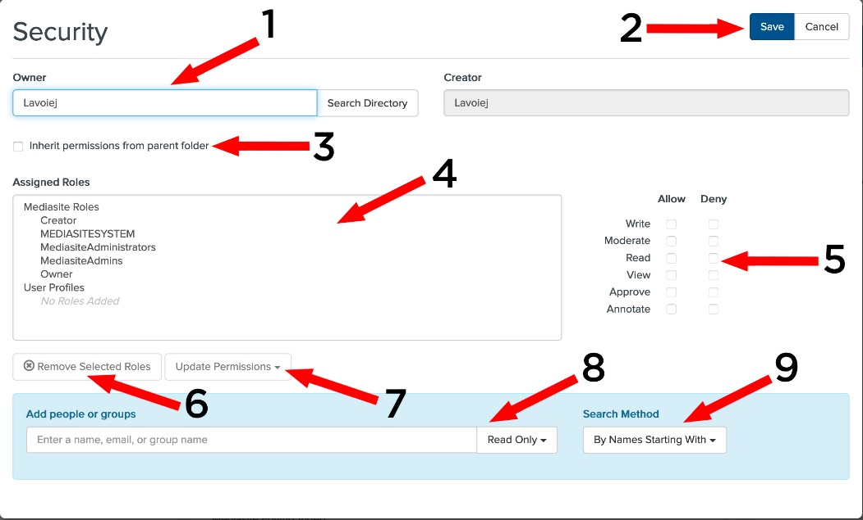
1: Owner – The user that owns this presentation. You can change this to another username to change ownership of a presentation. You may have to refresh your browser to see the change in ownership.
2: Save - Click here after you change the presentations permissions to make them happen
3: Inherit permissions from parent folder - If you click this, the permissions for this presentation will match those of the folder in which it sits on the server. You will not be able to add users/roles (4) or modify the permissions for those users/roles (5).
4: Assigned Roles - The list of User/Roles and Groups that are either Allowed or Denied the permission to Read / Write and View the presentation. To have Groups made (and people added to them), please contact your MediaSite Administrator.
5: Presentation Permissions – Click allow or deny, to specify if the User (or Role) can:
Write – User (or Role) can update the presentation settings.
Moderate – The user can view and approve questions from the audience on the presentation's Q&A Forum page. Questions will be forwarded to the email address associated with the user's profile (unless the user opts out). If a user is assigned Moderate and Annotate permissions, they can moderate a presentation’s annotation discussions.
Read – User (or Role) can see that the presentation exists. They will not be able to watch the presentation.
View – User (or Role) can watch the presentation.
Approve – User can comment on the presentation as part of a content approval workflow, review edited versions, recommend changes and approve or reject updates. User can’t edit the presentation. (Currently the REA process is not enabled on the server)
Annotate- Allows showcase users the ability to annotate the presentation.
6: Remove Selected Roles - Clicking on a User/Role/Group in the Assigned Roles box and then clicking here will remove them from the list.
7: Update Permissions -This button will change the presentation permission settings for the user/role/group that is selected in the Assigned Roles box. It will not set multiple sets of permissions at one.
8: You can add Users and Groups to the Assigned Roles box here. You can determine the starting permissions with the dropdown box to the right of the search box.
9: Search Method: Determines the search method to find Users and/or Groups. You can either search “By Names starting with” or “By Names Containing”.

