____________________________________
Student’s Name:

____________________________________
Date of birth:

____________________________________
Student’s E-mail:

____________________________________
Canadian School Name:

Your photo
here

Arrival Information

____________________________________________________________________________

Canadian City:

Arrival Date / Time:

Flight Number:

Pick Up: Yes No

Ending Date:
Student’s Information

____________________________________________________________________________
Homestay Request

Cellphone:

Allergies:

Special Conditions:

Homestay Meals Plan: 2 meals · 3 meals

Emergency Contact:
Brief Student’s Presentation

____________________________________________________________________________

(I am…, hobbies, personality, what i like, goals in life, etc…)

Please make sure to read and sign our service and cancellation policy. We require a signed copy of archive storage.

Send us a copy of your receipt at: lyne@caservices.ca

Remember: Before your trip, be sure to let your host family know in case you requested transportation and us at CAS!

It’s lot easier to communicate trough What’s App! Write your phone number down _________________ 😊
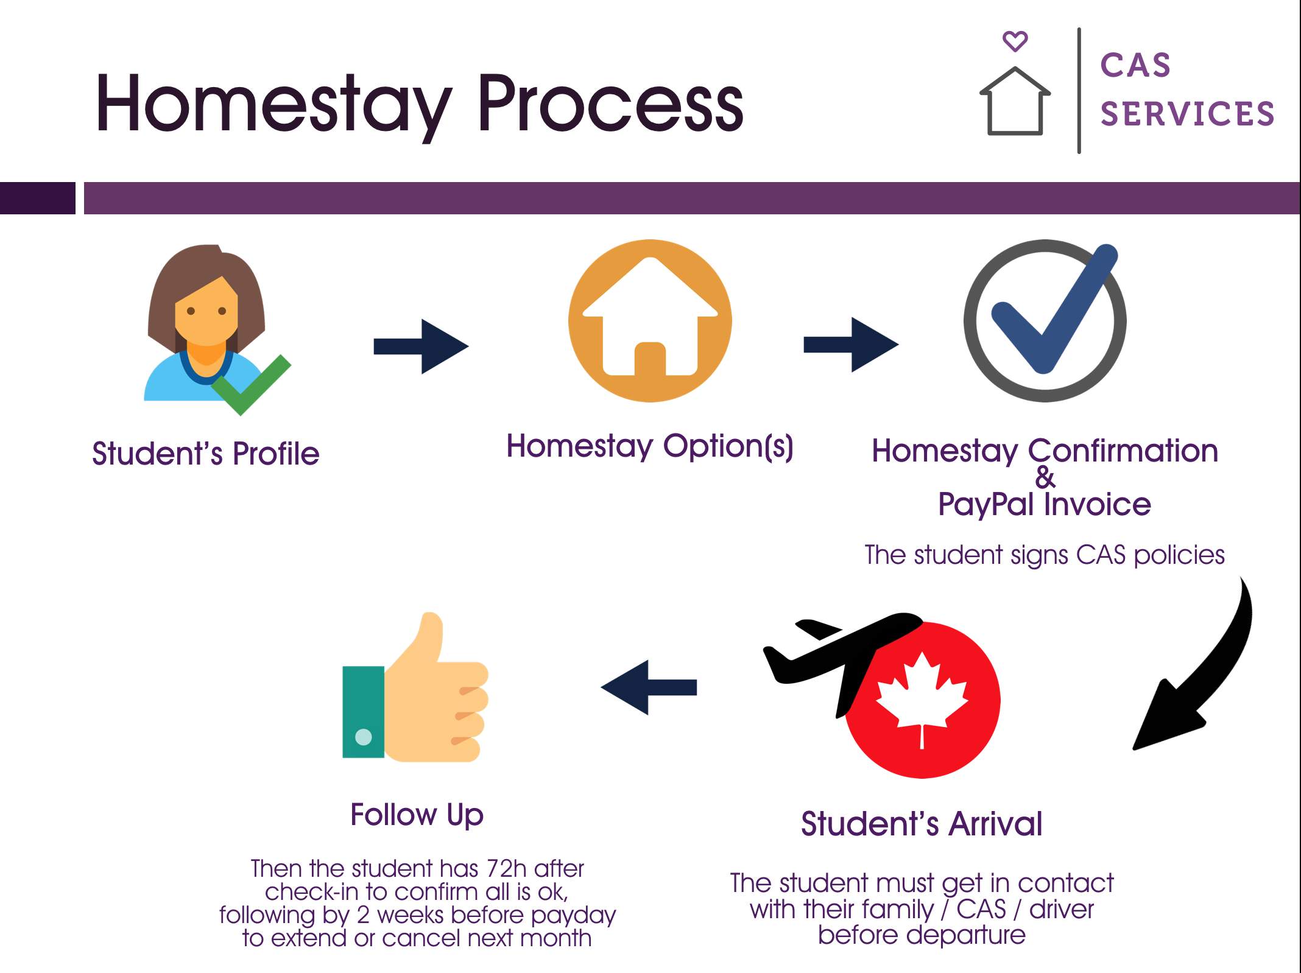

Homestay Guidelines for Students.

Communication and trust:

Your host family will make you feel a part of the family! Try your best to communicate with them about any inconvenience that may arise on your behalf. Host families are friendly and are always predisposed to help you make you feel right at home. The more you interact with your host family, the better you will adapt to your new environment. Remember, the fundamentals for a great Canadian experience with your new family lies in communication, trust, flexibility and openness.

Cultural diversity in Canada:

You must be willing to learn from and accept the many different cultures you will meet in Canada. Canadian families possess a wide range of distinct characteristics, and may even consist of families who emigrated and have lived in Canada for a long time now and speak fluent English and/or French.

Remember that Canada is famed for its acceptance of people from all over the world, which only contributes to an incredible diversity that benefits not only the country but our students as well, as it will offer you a unique glimpse into a global vision of the world. At CAS, we have a network of families from all over the world who will speak to you in English or in French (where it applies), which in turn will have you speaking fluently in no time.

Food:

It’s important for you to remember that the cooking at your homestay family will be different from the one you have at your home country! If the flavor of one kitchen varies from family to family, imagine what happens when you change countries! Be open to discuss the things that you don’t specially like, and if you really did like something for dinner, let them know! It’s always nice to receive a well-earned compliment. Be flexible; it’s all a part of your experience as an international student.
Canada’s eating schedule differ to those of other countries around the world., as well as the size of the portions consumed. If you have additional nutrition needs, have allergies or need more food than a regular diet provides, we suggest you acquire your products on your own.
Breakfast generally consists of juice, coffee or tea and cereal of toast with jam or peanut butter. Lunch consists of a sandwich and a piece of fruit, dinner being the strong meal of the day, which consists in a portion of protein and a side of vegetables or rice. Remember to wash your plates after you’re done with your meal, or place them in the dishwasher, and help tidying up the kitchen.
Curfew:

Remember to ALWAYS let your host family know where you are when you go out. Every family has their own curfew limits, which you must respect. If you’re planning on having dinner out, do let your host family know, so they don’t wait for you in vain. Being RESPECTFUL and kind to your host family will only help to make things great!

Guests:

Avoid bringing guests without permission to your host family’s house. They must know and authorize any visitors you intend on having. If you want to invite a friend over, ask beforehand and with as much anticipation as possible. Canada is a country where planification of all kinds is common practice, and a way to show respect. Nonetheless, remember it’s strictly forbidden to have friends over to spend the night.

Volume level:

There should be no excessive noise or use of the kitchen after 10 pm. If you are late one night, be mindful of your family’s rest and avoid making noise in excess, as well as avoiding talking over the phone or turning on the TV outside of the permitted hours.

Phone calls:

Be sure to ask your family when’s a good time to receive a call during the day. Many families use the home phone line for work or emergency related circumstances so please do not spend too much time on a phone call. If you’re planning on making a long distance call, be sure to purchase your own card for it.

Laundry:

Your host family will let you know how and when you will be able to use the washing machine. In some cases, there are designated times for the use of it, and may or may not offer to do your laundry. IT is not the obligation of your host family to do your laundry for you. It is your responsibility to do your own laundry.

Bathroom:

If you are sharing a bathroom with other members of the family, they will let you know when you can use it and for how much time. It’s important for you to remember that in foreign countries showers tend to be 10 to 15 minutes tops. Remember to always be clean, and leave the bathroom in the condition in which you found it.

Cleanliness:
It’s uncommon for host families to employ help with domestic duties. Everyone is responsible for his or her own bedroom. Do not leave your personal items unattended or in a disorderly fashion.
However, you are not responsible for domestic chores around the house, to take care of smaller children, to mow the loan, etc… but you are welcome to offer your help if you so wish. Being an active part of your host family will surely be greatly appreciated.

Pets:

Pets are considered to have equal rights to humans in Canada. Pets are not allowed in your bedroom, but are free to roam the house as they wish. It is not uncommon for family pets to enjoy activities with the host family and for them to live inside the house.

House care:

Be mindful of your household! If there’s any damage to the house, for which you are responsible, you might lose the entire security deposit of $500. If you have any doubts over the operation of any in-house appliance, please be sure to communicate with your host family. Report any damage you may find to your host family as soon as you become aware of it. Do not lose your keys! A lost key usual amount to change the locks of the house is approximately $180 CAD.

Water, electricity

Canada is famed for its ecological awareness. The use of resources such as water, electricity and gas tend to be expensive, so there is great care in their use. Do not leave any lights on if you’re not using them. Close the refrigerator door, do not take long showers and close the sink valve when brushing your teeth.

Emergencies, Insurance:

In case of emergency, you may call 911 to request an ambulance or police support. There is a $300 CAD fee for the service although you can always be refunded through your insurance. Remember to always carry your insurance information with you (policy number, emergency numbers) in your wallet or purse. Share this information with your host family.

Holidays:

If you’re planning on staying in Canada during the holidays, or accompany your host family on their own plans, remember that you must pay for your own expenses (hotel, transport, tickets and personal expenses). Minors must always be accompanied by an adult. Students that are 16 years old or less must contract the services of the airline custody ($150 CAD approximately). An additional fee will be charged to take the minor to the airport and make sure he will take off safely. $200 Cad. will be added for the service. It will take around 4 hrs of professional services.

Guidelines:
Even when you are paying for your own expenses, remember that you are still a guest and must behave accordingly. You must show respect towards your host family in the same way you would show respect to your own. If there ever occurred an incident which involved violence either physical or verbal, either from your or your family’s behalf, you will be removed from the family household immediately.
The incident will be reported to the police and legal action may proceed. If you have any doubts or uncertainties regarding your hosting accommodation, remember to always try dialogue and respect above all. Your stay in Canada is not only academic, but also involves your personal growth.
If your situation does not improve, you can contact our homestay coordinator Lyne Vezina by e-mail: lyne@caservices.ca or by phone +1 613 325 0822 who will resolve the matter in as short a time as possible.

Payment:

If you are planning to extend your stay in Canada, the payment with regard to your accommodation must be made one month prior to the end of your stay. Remember, in case of a delay in payment, there will be a 10% penalty fee (per day). If you are no longer planning to continue with your host family you must give us 2 weeks notice, so your current host family is not paid for another 4 weeks. It is strictly forbidden to come to personal agreements with the host family. If you choose to do so, we will not be able to help you, should you encounter any problems.

Cancellations:

Remember that your first weeks are meant for you to adapt and that your experience to the diversity of cultures and customs, as well as differences in language and context will challenge you depending on your previous experience, and how open you are willing to be. Canadian culture is very direct and honest, which can be unsettling for foreigners. Regardless, these are qualities that are highly valued in Canada, and are always meant to avoid misunderstandings. Remember that it is well within your right to practice honesty in a direct manner, always reminding yourself to be cordial and kind.
If it exist a personal reason for your inability to form a bond with your host family before the first 4 weeks elapsed, it’s important that you let us know with two weeks notice; on the contrary, there will be a penalty fee. You have 72 hours to confirm if your host family suits you fine. If that is not the case, contact your CAS coordinator to request a change. If you request a change after the first 72 hours have elapsed, there will be a surcharge of $150 CAD.

Use of alcohol and drugs in Canada / Law:

The use of drugs, alcohol, tobacco and any crime such as acts of violence, minor (or major robberies) or bad behavior such as throwing house parties without consent, inviting guests over to spend the night, taking things without express approval, property and moral damage, have serious consequences that may result in the cancellation of your study program and your housing in Canada, and will likely result in your deportation from the country.

The person responsible for the student will be notified immediately and will have 24 hours to send a ticket back home. If this condition is not met, the program coordinator is allowed to report the student to the police and to immigration authorities. A case file will be opened and the rule of Law will abide. The student himself or the responsible parties will absorb all expenses related to the deportation of the student. This scenario will close the doors of Canada to any foreigner who commits such a fault, whether minor or major.

Agreement

I, ___________________________________________, student of Canadian Accommodation Services international program, do hereby consent to following the rules and guidelines of my study program covering the following period
from _______________________ to ___________________________, year ________ at the School _______________________________ with address on __________________________________________________.

I ______________________________, have read and agree with the behavioural guidelines hereby outlined and accept the full responsibility of failing to abide by them, recognizing the probable cause as being the cancellation of my study program, if the cause is to be attributed to my behaviour and actions and will waiver my right to a reimbursement and may cause my deportation from Canada effective immediately.

I ______________________________, have read and agree on the policies regarding General Guidelines, Cancellation and Refund policies that pertain to CAS Canadian Accommodation Services.

______________________________________________________________________________
Student Signature

_________________________________________________ ____________________________________________________
Date Place

Name: ______________________________________________________________________________________
(parent/guardian signature if student is a minor)

Signature: __________________________________________________________________________________

(parent/guardian signature if student is a minor)

