PLAR (Prior Learning Assessment & Recognition)

Self-Assessment Guide

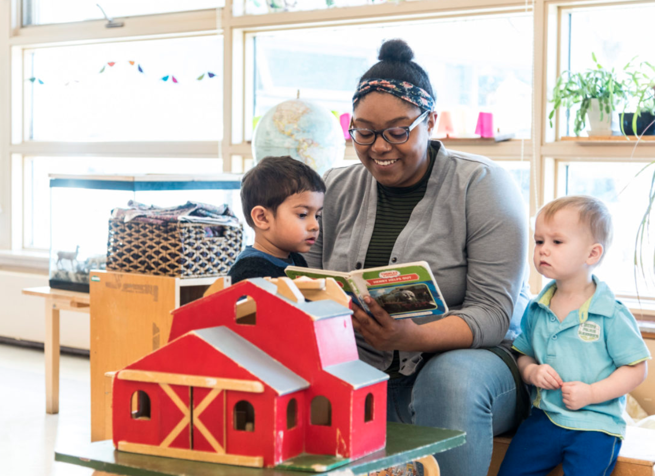

Practicum 1 (FAM1234)

Table of Contents
Is PLAR for You? 1
Self-Assessment 2
Step 1: Work Experience Checklist 2
Step 2: Evidence of Learning 3
Evidence of Learning for FAM1234 4
Step 3: Self-Evaluation of Competencies 6
Step 4: Employer Verification Form 11
PLAR Assessment 19
Tables to Submit 24
Experiences and Reflections 24
Routines and Transitions 26
Professional Conduct 27

Is PLAR for You?

The purpose of this resource guide is to help you determine whether you are eligible to apply for PLAR for FAM1234 (Practicum 1). This process is designed for students who have significant experience in the field of Early Childhood Education. There are several steps involved in this process:
- Complete the Self-Assessment in this guide.
- If you have met the requirements that are outlined in the Self-Assessment, send your completed Self-Assessment to the PLAR office.
- If you are eligible to continue with the application process, the PLAR office will contact you with details on paying the fee and completing the PLAR Assessment.
- Complete the PLAR Assessment and submit it to the PLAR office.

- An assessor will evaluate your application and you will be notified of the results by the PLAR Office. If the assessment criteria have been met, the grade P will appear on your transcript.

Exemptions vs. PLAR
If you do not have work experience but have instead previously taken similar courses through a recognized post-secondary institution, you may be eligible for a course exemption. This is different from the PLAR process. You must complete a request for an exemption through the Registrar’s Office. For more information, visit the Registrar’s Office: https://www.algonquincollege.com/ro/advanced-standingexemptions/

For More PLAR Information
PLAR Office Phone: (613) 727-4723 x 7852
PLAR Office Email: plar@algonquincollege.com
PLAR Website: https://www.algonquincollege.com/plar/
College’s PLAR Policies: https://www.algonquincollege.com/policies/files/2023/04/AA06.pdf

Self-Assessment

The first step in the PLAR process for FAM1234 requires that you complete this self-assessment form. As you do so, you will have the opportunity to reflect on your own work experience to ensure that you are able to demonstrate the knowledge and skills that are expected of a student who has successfully completed Practicum 1 (FAM1234).

The information you provide in this self-assessment form will help you and the PLAR office to determine your eligibility.

Step 1: Work Experience Checklist

Complete the following table by placing a checkmark under either “Yes” or “No.”

Criteria | Yes | No
You have a total of 300 hours of paid work experience where you worked directly with children.
Those 300 hours were in the capacity of an educator (work as a lunch supervisor is not considered equivalent and will not be accepted).
Those 300 hours were in one of the following settings:
- licensed home childcare
- a licensed childcare centre
- a drop-in child and family centre
- a preschool
- a kindergarten program in a school
- a before-and-after program in a school
Your work experience is current within the last 3 years.

Eligibility Check: | If you answered “Yes” to all of the eligibility criteria above, you may be a good candidate for PLAR for FAM1234. Please continue onto step 2.

Step 2: Evidence of Learning

On the following pages, you will see a table that reflects the CLOs (Course Learning Outcomes) for FAM1234. Complete the table as directed in steps 1 and 2.

- Read through the CLOs that appear in bold in the two tables below. The bullet points underneath each CLO are skills you may have demonstrated which could serve as evidence of those requirements; you may use those to help strengthen your understanding of each CLO. Once you are comfortable with the details of each CLO (in bold), provide evidence of how you have met the requirements by reflecting on your professional experiences and including details of specific situations where you have demonstrated those particular skills.

- Rate your comfort level with each CLO, according to the scale below:

5 = I am able to demonstrate the learning outcome well enough to teach it to someone else.
4 = I can work independently to apply the learning outcome.
3 = I need some assistance in using the outcome.
2 = I am developing skills and knowledge for this area.
1 = I have no experience with the outcome.
In order to be considered eligible for PLAR for FAM1234, you will need at least a 4 or a 5 for each CLO.

Use of Generative AI

Under Algonquin College Policy AA48 – Academic Integrity, “Academic work submitted by learners is evaluated on the assumption that the work presented by the learner is their own” and defines contract cheating as “[a] third-party completing work, with or without payment, for a learner, who then submits the work as their own, where such input is not permitted.” Using content generated by AI and claiming it as your own work is considered contract cheating. The PLAR process is intended to reflect your own knowledge and abilities, and any violations of these expectations will be brought forward as instances of academic misconduct under this policy and may result in disqualification from the assessment.

Evidence of Learning for FAM1234

CLOs | Details of Requirements | Evidence of Learning  Include details of specific work situations where you have demonstrated each CLO | Level of Competence  (1-5)
CLO1 | Apply observational skills to collect information about children and the early learning environment  - Practice using observational tools to gather relevant information on the children and the environment.  - Observe strategies used in routines and transitions.  - Practice using guided questions to further understand the children and the environment
CLO2 | Integrate theoretical knowledge with professional expectations to develop responsive relationships with children and families.  - Engage in building responsive relationships with the children and families.  - Practice engaging in professional relationships with the educators in the program
CLO3 | Reflect on emerging knowledge and skills to identify areas for growth.  - Use reflections to identify areas of strengths, growth, and needs.  - Reflect on feedback and areas of growth provided by educators and mentors.  - Create learning goals based on feedback from educators and mentors.  - Collaborate with the educators to develop self-awareness and professional practice.
CLO4 | Participate in learning opportunities to support children’s learning and development  - Engage with the children and educators in a meaningful and professional manner.  - Practice fostering interactions that support respect and diversity.
CLO5 | Introduce relevant and appropriate materials that reflect children’s interests and abilities  - Determine age-appropriate materials for children and the environment based on observations.  - Discuss appropriate materials with the educators to support children's interests and abilities.
CLO6 | Engage in professional verbal and written communication  - Apply effective communication and respective strategies when working directly with children, families, educators and colleagues.  - Use clear and concise written communication to convey information
CLO7 | Follow agency’s policies and procedures relating to the role of the educator  - Adhere to the policies and procedures outlined by both the agency and the Practicum 1 manual
CLO8 | Use strategies and techniques to initiate and lead routines and transitions.  - Discuss the different techniques to support children through routines and transitions.  - Actively practice routines and transitions.  - Facilitate and lead all routines and transitions.

Eligibility Check: | If you assigned yourself a 4 or a 5 for all CLOs, you may be a good candidate for PLAR for FAM1234. Please continue onto step 3.

Step 3: Self-Evaluation of Competencies

In the following table, you will see a list of specific competencies/skills from the Practicum 1 Competency Manual. Students who receive credit for this first practicum must be able to reliably demonstrate each one. After carefully reading through the list, place a checkmark in the “Yes” column if you feel that you have reliably demonstrated each skill during your work experience.

 | Consistently Demonstrates
 | Yes | No
Professional Conduct
- Is punctual at all times
- Understands student’s role and is accountable at all times
- Accepts and fulfills all student responsibilities given by the agency as well as the college
- Adheres to the agency’s policies and procedures
- Is self-motivated, takes initiative and is adaptable/flexible
- Models a professional appearance by wearing appropriate clothing for both the indoor and outdoor environment
- Practices problem-solving during challenging situations
- Maintains strict confidentiality for all information acquired during practicum
Communication with Colleagues
- Actively listens when communicating with colleagues and responds appropriately or asks questions for further clarification, if applicable
- Displays respectful and professional communication (verbal and written) with colleagues, and maintains professional boundaries
- Maintains a professional demeanour when receiving constructive feedback from the onsite supervisor and educators in the program
- Asks for direction and clarification from onsite supervisor and follows through on the feedback
- Shares observations of children with educators
Communication with Children and Families
- Practices speaking slowly, concisely, maintains eye contact, and actively listens to the children
- Observes the educators communicating with the children and families, and uses these strategies to practice professional interactions
- Observes the educators using age-appropriate language strategies to support children’s learning and uses the techniques consistently to guide children throughout the day
- Asks open-ended questions when appropriate
- Responds appropriately to children’s verbal and non-verbal communication/cues (eg. Support self-regulation, models language)
- Acknowledges families upon arrival in the program (at the beginning of the day)
- Shares information about the child’s day with the families, with permission from the onsite supervisor (if applicable)
- Observes and actively engages with children to learn about their emerging abilities, interests, and ideas
- Displays non-judgmental understanding of diverse family systems
Child Guidance
- Establishes and maintains eye contact
- Acknowledges positive behavior
- Works comfortably with a child on a one-to-one basis
- Works comfortably with children in a group setting
- Consistently follows through on expectations for individuals within the group
- Models prosocial behaviours
- States directions in a clear, positive manner
- Practices using clear expectations and appropriate language
- Gets down to the child’s level when interacting
Building Responsive Relationships
- Observes the educators interacting with the children to learn techniques for creating meaningful relationships. Demonstrate the ability to build rapport, and understand each child’s unique abilities
- Maintains a sense of humour and displays calmness/patience
- Responds appropriately to children’s cues, needs and interests (eg. Displaying affection, support self-regulation)
- Uses positive and encouraging age-appropriate language with the children
- Follows through on commitments to children
- Acknowledges each child by name
- Interacts in a gentle and supportive manner (eg. get down to child’s level, maintain eye contact, use appropriate tone of voice)
- Demonstrates respect for diversity and individuality in all interactions (eg. listen attentively, celebrate all children’s strengths equally, adapt interactions to meet individual needs)

Supervision
- Supervises children in both indoor and outdoor environments with the direct guidance of the onsite supervisor
- Is aware of the number/ratios of children in the environment (indoor/outdoor) at all times
- Scans children’s environment frequently and positions self to maximize view of the area
- Supervises children on field trips with support from onsite supervisor (eg. walks, if applicable)
- Spends majority of the time interacting with children, not colleagues
Routines and Transitions
- Demonstrates awareness of the daily schedule. By the end of practicum, students should be leading routines and transitions without prompts from their onsite supervisor
- Uses strategies to guide children through routines and transitions. By the end of practicum, students should be leading and facilitating all routines and transitions
- Models appropriate safety and health practices
- Maintains awareness of the individual child as well as the whole group during the routine and transition
- Smiles and greets children and families upon arrival (if applicable)
- Encourages self-help skills based on the child’s abilities
- Dresses children appropriately for the weather. Recognizes when a child requires assistance, encourages autonomy and self-help skills
- Aware of children who require a change of clothes. Assists in changing clothing if soiled or wet from play (if applicable)
- Makes sure the child’s clothes are easily accessible before dressing (infant, toddler, preschool)
Lunch/Snack
- Provides a pleasant and orderly transition from the previous activity to the eating area
- Is aware of allergies and takes necessary precautions to prevent allergic reactions
- Ensures the children’s hands are washed before and after snack/lunch
- Serves the children promptly and according to dietary needs (eg. liquids for infants)
- Provides a pleasant, calm, relaxed social atmosphere during snack/lunch and engages with the children
- Encourages conversation between the children (appropriate for the age group)
- Encourages self-help achievements and recognizes individual skills and provides assistance when necessary
- Prepares and maintains a sanitary environment
- Respects the family’s practices regarding specific foods
- Involves the children in preparation of tables and food as much as possible (if applicable)
- Encourages children to clean up after themselves (if applicable)
- Records the child’s food intake according to agency’s practices (if applicable)
- Holds infant comfortably and maintains eye contact while bottle feeding (if applicable)
- Provides opportunity for the infant to burp safely and comfortably (if applicable)
Sleep/Rest Routine (if applicable)
- Understands and carries out the agency’s schedule and practices including room arrangement and sleep documentation
- Assists the child(ren) to prepare for rest
- Allows children to seek their own comfortable position for sleep and/or relaxation
- Provides physical comfort if required, (e.g. pats back, etc)
- Recognizes symptoms of tiredness and responds accordingly if applicable (infant practicum)
- Checks on children during sleep time (if applicable)
- Provides a smooth transition for the children to return to the program upon waking up (uses a quiet voice, assist in bathroom routine, directing children to a quiet activity)
Bathroom and Diaper Routine
- Provides help with clothing if necessary and appropriate
- Ensures that the children follow all hand washing protocols. Assists if necessary
- Respects the child’s need for privacy
- Recognizes child’s discomfort and takes initiative in changing wet or soiled diapers
- Follows procedures set out by the agency (eg. sanitary practices)
- Disinfects change table and washes hands before and after each diaper change (if applicable)
- Is vigilant in protecting the child’s physical safety during the diaper routine, by keeping a hand on the child at all times (if applicable)
- Talks to the child about the process while changing: describes what they are doing (if applicable)
- Interacts with the child during the diaper routine, if applicable (e.g. plays with toes, etc.)
- Is matter-of-fact during process; avoids negative facial expressions or comments (if applicable)
- Records child’s elimination; reports any abnormalities (e.g. stool consistency, etc.) to the On-site Supervisor if applicable.
Learning Environment and Curriculum
- Keeps the environment organized, safe and tidy
- Encourages children to keep the environment safe and tidy
- Identifies and protects children from dangerous or unsafe materials
- Brings a variety of children’s books. The children’s books connect to the children’s interests and observations and are used to enhance learning experiences
- Brings a variety of loose parts to use with the children. The loose parts connect to the children’s interests and observations
- Models respect for the equipment
- Actively participates in group time
- Actively participates in indoor/outdoor activities

Eligibility Check: | If you checked “yes” for all of the competencies in the table above, you may be a good candidate for PLAR for FAM1234. Please continue onto step 4.

Step 4: Employer Verification Form

All PLAR applicants will need to ask their previous or current employer to fill out the Employer Verification Form. If your work experience is in a school setting, you will also need to submit formal documentation from Human Resources that indicates your role, the number of hours you have worked as an educator, and the dates of employment. If your work experience is in a licensed centre, you do not need to submit this documentation.

Ask your previous or current employer to fill out the Employer Verification Form. Make sure that you ask a direct supervisor who has seen you “in action” and can speak to your ability to demonstrate all 70 competencies.

After you receive the completed form from your supervisor, answer the following questions:

Criteria | Yes | No
Did your employer indicate that you worked at least 300 hours as an educator?
Does the employment period that is indicated on the form fall within the last 3 years?
Was “Yes” checked for all competencies?
Did your employer circle “Yes” to indicate that they are confident in your skills and that they believe you are ready to move onto the next practicum?
If your work experience is in a school, did you receive formal documentation from Human Resources that indicates your role, the number of hours you have worked as an educator, and the dates of employment?

Eligibility Check: | If you checked “yes” in response to all five questions above, you may be a good candidate for PLAR for FAM1234.  If you did not meet the eligibility check for any of the steps above, you are not eligible for PLAR for FAM1234 and you must register for the course.  If you have met all of the requirements from steps 1-3 in this document, the next step in the process is to apply online for PLAR at the following site:

Employer Verification Form

EARLY CHILDHOOD EDUCATION

SCHOOL OF HEALTH AND COMMUNITY STUDIES

Algonquin College

Employer: _________________________________________________________________

Position/Relationship to the Employee: __________________________________________

Name of Employee: __________________________________________________________

Employee’s Role/Position: ____________________________________________________

Employment Period: __________________________ to _____________________________

Has the employee worked at least 300 hours as an educator? __________

Using the checklist that appears on the following pages, please check “Yes” or “No” to evaluate the employee’s ability to consistently demonstrate each skill.

 | Consistently Demonstrates
 | Yes | No
Professional Conduct
- Is punctual at all times
- Understands student’s role and is accountable at all times
- Accepts and fulfills all student responsibilities given by the agency as well as the college
- Adheres to the agency’s policies and procedures
- Is self-motivated, takes initiative and is adaptable/flexible
- Models a professional appearance by wearing appropriate clothing for both the indoor and outdoor environment
- Practices problem-solving during challenging situations
- Maintains strict confidentiality for all information acquired during practicum
Communication with Colleagues
- Actively listens when communicating with colleagues and responds appropriately or asks questions for further clarification, if applicable
- Displays respectful and professional communication (verbal and written) with colleagues, and maintains professional boundaries
- Maintains a professional demeanour when receiving constructive feedback from the onsite supervisor and educators in the program
- Asks for direction and clarification from onsite supervisor and follows through on the feedback
- Shares observations of children with educators
Communication with Children and Families
- Practices speaking slowly, concisely, maintains eye contact, and actively listens to the children
- Observes the educators communicating with the children and families, and uses these strategies to practice professional interactions
- Observes the educators using age-appropriate language strategies to support children’s learning and uses the techniques consistently to guide children throughout the day
- Asks open-ended questions when appropriate
- Responds appropriately to children’s verbal and non-verbal communication/cues (eg. Support self-regulation, models language)
- Acknowledges families upon arrival in the program (at the beginning of the day)
- Shares information about the child’s day with the families, with permission from the onsite supervisor (if applicable)
- Observes and actively engages with children to learn about their emerging abilities, interests, and ideas
- Displays non-judgmental understanding of diverse family systems
Child Guidance
- Establishes and maintains eye contact
- Acknowledges positive behavior
- Works comfortably with a child on a one-to-one basis
- Works comfortably with children in a group setting
- Consistently follows through on expectations for individuals within the group
- Models prosocial behaviours
- States directions in a clear, positive manner
- Practices using clear expectations and appropriate language
- Gets down to the child’s level when interacting
Building Responsive Relationships
- Observes the educators interacting with the children to learn techniques for creating meaningful relationships. Demonstrate the ability to build rapport, and understand each child’s unique abilities
- Maintains a sense of humour and displays calmness/patience
- Responds appropriately to children’s cues, needs and interests (eg. Displaying affection, support self-regulation)
- Uses positive and encouraging age-appropriate language with the children
- Follows through on commitments to children
- Acknowledges each child by name
- Interacts in a gentle and supportive manner (eg. get down to child’s level, maintain eye contact, use appropriate tone of voice)
- Demonstrates respect for diversity and individuality in all interactions (eg. listen attentively, celebrate all children’s strengths equally, adapt interactions to meet individual needs)
Supervision
- Supervises children in both indoor and outdoor environments with the direct guidance of the onsite supervisor
- Is aware of the number/ratios of children in the environment (indoor/outdoor) at all times
- Scans children’s environment frequently and positions self to maximize view of the area
- Supervises children on field trips with support from onsite supervisor (eg. walks, if applicable)
- Spends majority of the time interacting with children, not colleagues
Routines and Transitions
- Demonstrates awareness of the daily schedule. By the end of practicum, students should be leading routines and transitions without prompts from their onsite supervisor
- Uses strategies to guide children through routines and transitions. By the end of practicum, students should be leading and facilitating all routines and transitions
- Models appropriate safety and health practices
- Maintains awareness of the individual child as well as the whole group during the routine and transition
- Smiles and greets children and families upon arrival (if applicable)
- Encourages self-help skills based on the child’s abilities
- Dresses children appropriately for the weather. Recognizes when a child requires assistance, encourages autonomy and self-help skills
- Aware of children who require a change of clothes. Assists in changing clothing if soiled or wet from play (if applicable)
- Makes sure the child’s clothes are easily accessible before dressing (infant, toddler, preschool)
Lunch/Snack
- Provides a pleasant and orderly transition from the previous activity to the eating area
- Is aware of allergies and takes necessary precautions to prevent allergic reactions
- Ensures the children’s hands are washed before and after snack/lunch
- Serves the children promptly and according to dietary needs (eg. liquids for infants)
- Provides a pleasant, calm, relaxed social atmosphere during snack/lunch and engages with the children
- Encourages conversation between the children (appropriate for the age group)
- Encourages self-help achievements and recognizes individual skills and provides assistance when necessary
- Prepares and maintains a sanitary environment
- Respects the family’s practices regarding specific foods
- Involves the children in preparation of tables and food as much as possible (if applicable)
- Encourages children to clean up after themselves (if applicable)
- Records the child’s food intake according to agency’s practices (if applicable)
- Holds infant comfortably and maintains eye contact while bottle feeding (if applicable)
- Provides opportunity for the infant to burp safely and comfortably (if applicable)
Sleep/Rest Routine (if applicable)
- Understands and carries out the agency’s schedule and practices including room arrangement and sleep documentation
- Assists the child(ren) to prepare for rest
- Allows children to seek their own comfortable position for sleep and/or relaxation
- Provides physical comfort if required, (e.g. pats back, etc)
- Recognizes symptoms of tiredness and responds accordingly if applicable (infant practicum)
- Checks on children during sleep time (if applicable)
- Provides a smooth transition for the children to return to the program upon waking up (uses a quiet voice, assist in bathroom routine, directing children to a quiet activity)
Bathroom and Diaper Routine
- Provides help with clothing if necessary and appropriate
- Ensures that the children follow all hand washing protocols. Assists if necessary
- Respects the child’s need for privacy
- Recognizes child’s discomfort and takes initiative in changing wet or soiled diapers
- Follows procedures set out by the agency (eg. sanitary practices)
- Disinfects change table and washes hands before and after each diaper change (if applicable)
- Is vigilant in protecting the child’s physical safety during the diaper routine, by keeping a hand on the child at all times (if applicable)
- Talks to the child about the process while changing: describes what they are doing (if applicable)
- Interacts with the child during the diaper routine, if applicable (e.g. plays with toes, etc.)
- Is matter-of-fact during process; avoids negative facial expressions or comments (if applicable)
- Records child’s elimination; reports any abnormalities (e.g. stool consistency, etc.) to the On-site Supervisor if applicable.

Learning Environment and Curriculum
- Keeps the environment organized, safe and tidy
- Encourages children to keep the environment safe and tidy
- Identifies and protects children from dangerous or unsafe materials
- Brings a variety of children’s books. The children’s books connect to the children’s interests and observations and are used to enhance learning experiences
- Brings a variety of loose parts to use with the children. The loose parts connect to the children’s interests and observations
- Models respect for the equipment
- Actively participates in group time
- Actively participates in indoor/outdoor activities

The employee is applying to receive credit for the first practicum in Algonquin’s ECE program. If successful, they will skip the first practicum and move directly onto the second practicum. In your experience as a supervisor of the employee, do you believe they have consistently demonstrated the competencies listed above and are ready to move onto the second practicum?

(Please circle yes or no): Yes No

Signature: ___________________________________________________________________

Printed Name: _______________________________________________________________

Date: ______________________________________________________________________

Please provide your contact information if we feel we need to discuss any details with you:

Work email address: ____________________________________________________________

Work phone number: ___________________________________________________________

Thank you very much for your assistance.

PLAR Assessment

This section should only be completed if you have:
- Finished the Self-Assessment and determined that you meet all of the requirements
- Sent your Self-Assessment to the PLAR Office (plar@algonquincollege.com)
- Paid your PLAR fee
- Been notified by the PLAR office that you are able to move on with the process and complete the PLAR Assessment

On the following 3 pages are the questions you need to answer for the PLAR Assessment. The questions must be answered using the “Tables to Submit.” Once you have completed the tables, submit them to the PLAR office via email (plar@algonquincollege.com).

The questions are divided into the following three sections:
- Experiences and Reflections
- Routines and Transitions
- Professional Conduct

Experiences and Reflections
Answer the following questions. Record your answers in the tables provided in the “Tables to Submit” section and send the completed tables with your application.
- How have your interactions with children, families, and other educators been impacted by what you have learned in your ECE coursework at Algonquin? You may focus on specific courses, assignments, or experiences in the program that have helped you link theory (coursework) to practice (hands-on work with children and families). Please share two different reflections that highlight your understanding of how theory relates to practice.
- Share details of a time when you sought or received feedback from your employer and acted upon it.
- In Step 3: Self-Evaluation of Competencies, you’ll see different sections of competencies that are included in the Practicum 1 Competency Manual. Select one competency from each section (except for Professional Conduct, which will be focused on in another section). For each competency, provide a reflection (100-word minimum) of a specific scenario when you have demonstrated that competency in your experience in an early learning setting.
- Reflect on an interaction with children and/or families from your previous work experience. Provide two examples of how your approaches reflected the pedagogical principles of “How Does Learning Happen?” Identify which foundation(s) are evident and justify your choices. (Your discussion should be at least 100 words in length.)

Routines and Transitions
Review the competencies from your self-assessment, and keep them in mind as you watch the following video of an educator leading a snack time transition in a kindergarten room. https://www.youtube.com/watch?v=xMSwdGpp6ig
Answer the following questions. Record your answers in the tables provided in the “Tables to Submit” section, and send the completed tables with your application.
- What competencies did the educator in the video demonstrate?
  - Identify two specific competencies from the list above that you believe the educator in the video demonstrated.
  - Provide evidence of both competencies by discussing details of what you saw and/or heard in the video that led you to believe the educator was demonstrating those competencies. (Your response here should be very detailed and thorough)
- What specific skills within the children are being promoted during this transition activity?
  - List 3 skills from different developmental domains. Use the ELECT document so that you can provide the name and number of each skill. (Kindergarten skills begin on page 37 of the ELECT document which can be found at the following site: https://www.ultimateschoolagers.com/uploads/7/6/2/8/76285121/elect.pdf)
  - Discuss indicators of these skills by mentioning specific details from the video. (What did you see that led you to conclude that those skills were being promoted?)
Feel free to use the information below to help you identify the correct information in the ELECT document.
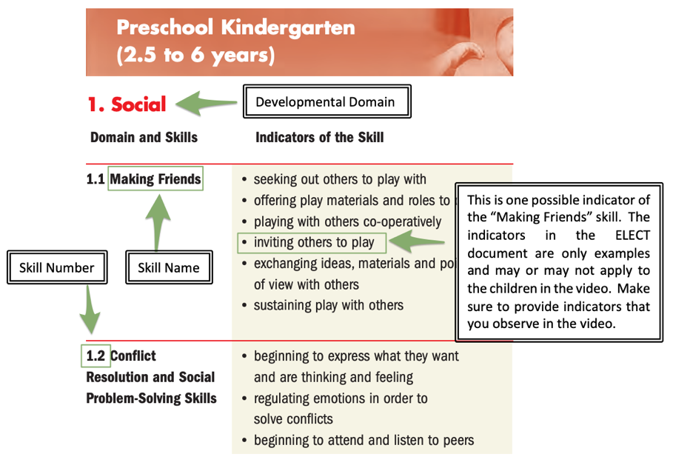
- If you were a co-educator in this program, how would you jump in to assist the educator and/or children?
- Evaluate the effectiveness of the transition shown in the video by identifying specific strategies that you think might improve the overall process. If you can’t identify strategies, explain why you believe this transition is effective as it is.

Professionalism
Answer the following questions. Record your answers in the tables provided in the “Tables to Submit” section and send the completed tables with your application.
- What does professionalism mean to you? Provide a specific example of how you demonstrate professionalism as an educator.
- Select three competencies from the “Professional Conduct” section of the list of competencies that you believe you excel at in your work experience. For each one, clarify why you are confident that you have clearly demonstrated the competency by providing a reflection (100-word minimum) containing specific examples from your experiences in an early learning setting.
- What is one competency from the area of Professional Conduct that you would like to improve? Explain why you feel there is room for growth in this area and discuss specific steps that could help you meet your goal.
- In the same video you watched above, identify three specific competencies from the “Professional Conduct” area of the list of competencies that you observed being demonstrated by the educator and justify your selection by providing evidence from the video.

Tables to Submit
Use the following tables to record your answers to the questions in the three sections above. Submit the completed tables to the PLAR office via email (plar@algonquincollege.com).

Experiences and Reflections
Connection of Theory to Practice
Reflection #1
Reflection #2
Reflection: Acting on Feedback
Provide details of your experience here…
Connections to Competencies
Area |  | Competency # | Competency Name | Reflection of Specific Scenario (minimum 100 words each)
Communication with Colleagues
Communication with Children and Families
Child Guidance
Building Responsive Relationships
Supervision
Routines and Transitions
Lunch/Snack
Sleep/Rest Routine (if applicable)
Bathroom and Diaper Routine
Learning Environment and Curriculum

Connection to HDLH

Routines and Transitions
Demonstrated Competencies
Area |  | Competency # |  |  | Competency  Name | Evidence of the Competency
Routines and Transitions
Routines and Transitions
Promoted Skills in Children
Skill | Domain |  |  | Skill Number (in ELECT) |  | Skill Name (in ELECT) | Indicators of the Skills
1
2
3
How would you assist?

Evaluate effectiveness of the transition:

Professional Conduct
How do you Demonstrate Professional Conduct?
Specific Example
Connections to Professional Conduct Competencies
Area |  | Competency # |  |  | Competency Name | Examples from your Experiences (minimum 100 words each)
Professional Conduct
Professional Conduct
Professional Conduct
A Professional Conduct Competency to Improve On
Competency #
Competency Name
Reason for need for improvement
Specific Steps to help you improve
Observed Professional Conduct Competencies
Area |  |  | Competency # |  | Competency Name |  | Evidence of the Competency
Professional Conduct
Professional Conduct

